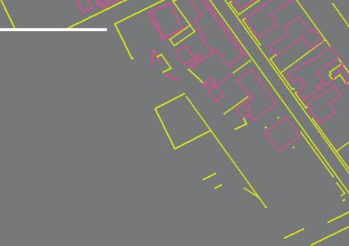

* Ground floor A1 unit
* Flexible lease terms
* Located within Llanelli Town Centre

|  |
| --- |
| **To Let**  **18a Cowell Street, SA15 1UU**  Llanelli.    **Offers in the Region of £3000 per annum** |



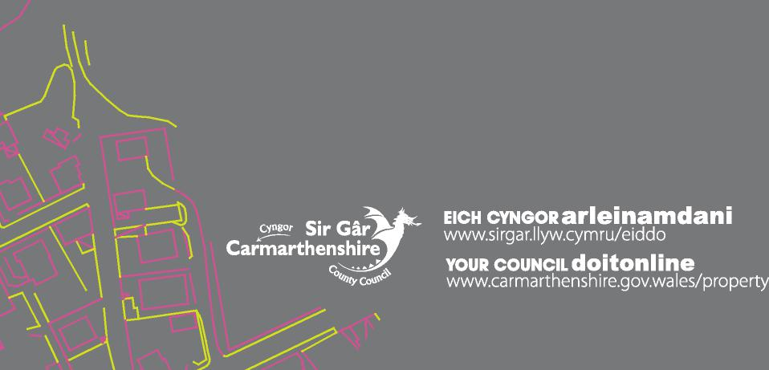

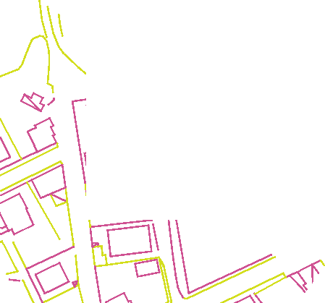

Description

A ground floor retail unit located in Llanelli town centre, close to Llanelli Indoor Market and St Elli Shopping Centre.

Accommodation

Gross internal area of approximately 15.8sqm (170 sq ft).

Services

The premises has its own electricity supply. The incoming tenant will be responsible for the transfer of the utilities into their own name and the payment of the bills.

None of the services have been tested and you should make your own enquiries in this regard.

Energy Performance Certificate

Energy performance rating: D

Consideration of Offers

We encourage applications from a wide range of existing and yet to be established businesses.

In the event of similar or competitive offers being received the Council will prioritise those that benefit Llanelli in the wider strategic context.

Business rates

RV £2,300 currently 100% small business rates relief

Lease Terms

Rent: £3,000 per annum exclusive

Term: 5 Years (although longer/shorter tenancy may be considered

Repairs/Insurance: Tenant internal and plate glass

Tenant required to make a contribution towards the Council’s cost of maintaining and insuring the building

Trade and bank references will be required, and the Council may require a guarantor.

Use A1.

Alternative uses of the property may be considered and prospective tenants are advised to check with the local planning authority as to the suitability of their proposals.

Legal costs

Each party is to be responsible for their own legal costs incurred in this transaction

For Further Information Please Contact:

County Hall

Carmarthen

SA31 1JP

**Alex Williams MPlan, Graduate Surveyor**

Tel no. 01267 242379

[Email: ADWilliams@carmarthenshire.gov.uk](mailto:Email:%20ADWilliams@carmarthenshire.gov.uk)

You will need to operate bilingually according to the Council’s policies including interior and exterior bilingual signs in the property.  There is an advice and assistance service as well as free translation and proof-reading available.  For information, go to [www.carmarthenshire.gov.wales/home/business](http://www.carmarthenshire.gov.wales/home/business) and click on ‘Welsh Language in business’

For information and help to work biligually, go to [www.carmarthenshire.gov.wales/home/business](http://www.carmarthenshire.gov.wales/home/business) and click on ‘Welsh Language in business’ Lawrlwythwch

These particulars are intended to give a fair description of the property, but are set out for guidance only. Their accuracy cannot be guaranteed and you should satisfy yourself by inspection or otherwise as to their correctness. Carmarthenshire County Council is obliged to consider all offers received in respect of this property up until the exchange of contracts. It is not obliged to accept the highest or any offer.



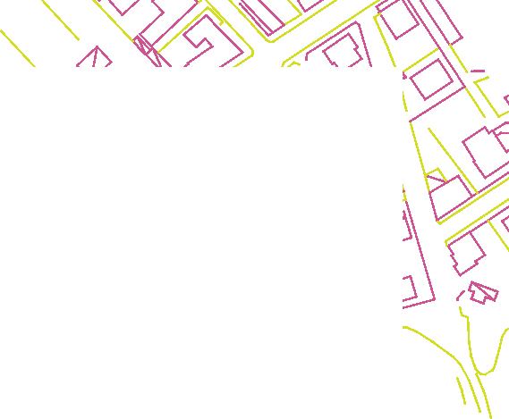

Notes

|  |
| --- |
|  |

GD4533