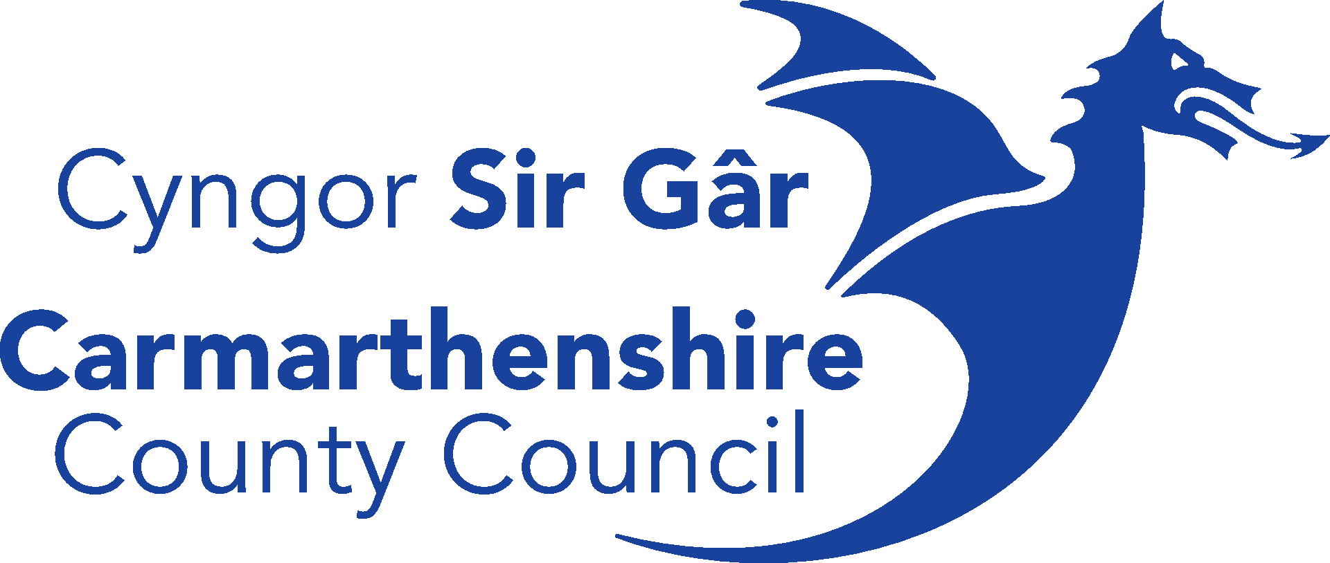



**Application Form**

**Community-led GBI Small Grants Scheme**

The Community-led Green and Blue Infrastructure (GBI) Small Grants Scheme supports local community groups, charities, and social enterprises in enhancing green and blue spaces across Carmarthenshire. This scheme aims to promote biodiversity, improve public spaces, and encourage community-led environmental initiatives.

Prospective applicants are encouraged to apply. Please note that late applications will not be considered. Please contact us if you have any questions about your application or would like to discuss your project idea. Comprehensive guidance on the scheme, including answers to the following questions, can be found on our website.

* Who is eligible to apply?
* How are applications processed?
* What types of expenditure are eligible, and what is the maximum funding available?

This scheme is delivered through Gwyrddu Sir Gâr, funded by the UK Government through the Shared Prosperity Fund with support from Carmarthenshire County Council. All responses received will be handled in accordance with our [Privacy Notice](https://www.carmarthenshire.gov.wales/council-democracy/data-protection/privacy-notices/community-bureau/).

**Please submit this form to** [**Greening@Carmarthenshire.gov.uk**](mailto:Greening@Carmarthenshire.gov.uk) **by Friday 6th June 2025.**

|  |  |  |  |  |
| --- | --- | --- | --- | --- |
| **SECTION ONE – APPLICANT INFORMATION** | | | | |
| **Organisation Name** |  | | | |
| **Primary Contact** |  | | | *This is main person who we would be discussing the application with.* |
| **Position** |  | | | |
| **Contact Email** |  | | | |
| **Organisation Address** |  | | | |
| **Post Code** |  | **Phone Number** |  | |
| **Status of your Organisation** |  | | | *i.e. the legal entity of your organisation, such as ‘constituted group’ or ‘community council’. If you are a registered charity, please also provide your reference number.* |

**Preferred Language for Correspondence** WelshEnglishBilingual

**SECTION TWO – ELIGIBILITY CRITERIA**

Please read Chapter 2 and Appendix A of the guidance for help completing this section.

**Is the proposed project located within at least one of the scheme’s target areas?**

|  |  |  |  |  |  |
| --- | --- | --- | --- | --- | --- |
| Ammanford |  |  | Llandovery |  | *Please mark appropriately.*    *The scheme aims to fund at least one project within each target area to ensure a broad geographical distribution and promote equitable access to funding across the county.*  *The scheme does not support projects outside Carmarthenshire.* |
| Carmarthen |  |  | Llanelli |  |
| Crosshands |  |  | Llanybydder |  |
| Cwmaman |  |  | Newcastle Emlyn |  |
| Kidwelly |  |  | St. Clears |  |
| Laugharne |  |  | Whitland |  |
| Llandeilo |  |  |  |  |  |
|  |  |  |  |  |  |
| If your proposal aims to deliver in other parts of the county in addition to one or more of the target areas, please explain here | | | |  | |

**Projects must align with at least one of the five following objectives. Which of the following objectives will your project contribute to in order to achieve tangible, physical improvements to Green and Blue Infrastructure?**

|  |  |  |  |  |
| --- | --- | --- | --- | --- |
| Improving Community Greenspace |  | Mitigating Environmental Pollution |  | *Please mark appropriately.*  *Please refer to 4.2 of the guidance for details.*  *Please note, this scheme does not support conceptual proposals or feasibility studies.* |
| Enhancing Biodiversity & Access to Nature |  | Demonstrating Innovative GBI Solutions |  |
| Promoting Placemaking & Town Centre Regeneration |  |  |  |

**Does your project aim to create or improve an open public space that is accessible without restrictions?**

|  |  |  |  |  |
| --- | --- | --- | --- | --- |
|  |  |  |  | *Please note, this scheme only supports projects that create/improve spaces that are publicly accessible without significant restrictions, such as financial costs or membership requirements for general access.*  *Spaces that require membership for specific uses (e.g., allotment plots) are accepted, as long as the overall space is open to the public.*  *Spaces with access limitations, like being locked at specific hours (e.g., at night), are also accepted.*  *Please note, this scheme only supports projects that are able to answer ‘Yes’ to this question.* |
| Yes |  | No |  |
|  |  |  |  |

**SECTION THREE – PROJECT PROPOSAL**

Please read Chapter 4 and Chapter 5 of the guidance for help completing this section.

**What is the name of your project?**

|  |  |
| --- | --- |
|  | *Don’t worry if this isn’t the final name you have settled on.*  *Welsh names are also encouraged.* |

**Please provide a summary of your project (max 500 words), including:**

* A brief overview of your project idea, activities, and how it will benefit the community;
* How you intend to utilise the funding; *Please refer to Section 4.4 and 4.5 of the guidance for eligible expenditure.*
* How your project will achieve at least two of the Expected Project Outputs (i.e., Creation or Enhancement of GBI; Community Engagement and Education; Volunteering Opportunities; Public Access and Enjoyment); *Please refer to Chapter 5 of the guidance.*
* How you will ensure long-term sustainability. *Applicants may consider community stewardship, volunteer involvement, integration with existing initiatives, or securing additional funding to maintain and expand the project’s impact.*

|  |
| --- |
|  |

**Where will your project be located?**

|  |  |
| --- | --- |
|  | *Please provide the specific location of your project, including any relevant landmarks or nearby areas for reference. If your site doesn’t have a postal address, please use* [*What3Words*](https://what3words.com/) *to provide an accurate location.*  *If your project spans multiple areas, please indicate the locations involved.* |

**Who owns/manages the land? Do you have permission to carry out work on this land?**

|  |  |
| --- | --- |
|  | *Please provide details of the landowner and the entity responsible for managing and maintaining the site (e.g., local authority, charitable trust, community group).*  *If applicable, please specify whether any formal agreements are in place or if permission has been obtained to carry out work on the land.* |

|  |  |  |  |
| --- | --- | --- | --- |
| **Total project cost** |  | **Grant amount requested** |  |
| **£** |  | **£** |  | *Eligible applicants can apply for a minimum of £1,000 and a maximum of £3,000, up to 100% of total project costs.* |

**Provide a breakdown of how your project costs have been estimated.**

This may include indicative supplier prices, costs from previous project, industry benchmarks, or professional advice. While final quotes are encouraged, they are not required at this stage — they will only be necessary subject to your project being awarded funding.

|  |
| --- |
|  |

**Will the project receive any additional funding match funding or in-kind contributions?**

Match funding is not required, but additional contributions are encouraged. If applicable, specify the source, amount, and whether the funding is secured or pending.

|  |
| --- |
|  |

**What partnerships or collaborations will be (or are already) involved in your project?**

Describe any existing/planned engagement, including key stakeholders, community groups, or organisations. Highlight any community interest or backing from local members.

|  |
| --- |
|  |

**Please provide any additional information below that you feel is relevant to your application.** *Applicants may consider providing additional information in relation to Section 6.2 of the guidance.*

Email attachments supplied alongside your submission are also welcomed.

|  |
| --- |
|  |

**DECLARATION**

I confirm that I have read the application guidance and believe I am eligible to apply.

I declare that the information given is accurate and true to the best of my knowledge**.**

**Please provide a signature below on the behalf of the Organisation:**

*Electronic signatures are accepted*

|  |  |
| --- | --- |
| **Signature** |  |
| **Print Name** |  |
| **Position** |  |
| **Date** |  |

**Please return to** [**Greening@Carmarthenshire.gov.uk**](mailto:Greening@Carmarthenshire.gov.uk)

The information provided in this application form will be retained by the local authority and used for monitoring, reviewing, and analysing the scheme.

To find out more about how we use your information, please contact our Data Protection Officer [dataprotection@carmarthenshire.gov.uk](mailto:dataprotection@carmarthenshire.gov.uk)

*Mae croeso i chi gysylltu gyda’r cyngor trwy gyfrwng y Gymraeg neu’r Saesneg*

*You are welcome to contact the council through the medium of Welsh or English*

Alternatively, please send paper copies to:

Community-led GBI Small Grants Scheme

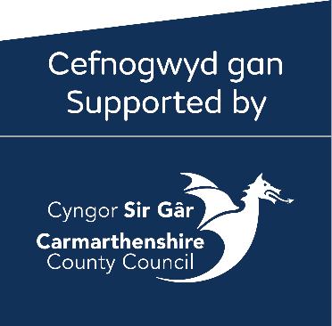Strategic Policy & Placemaking

3 Spilman Street

Carmarthen

SA31 1LE

**What Happens Next?**

**After Submitting Your Application:**

* You will receive a confirmation email acknowledging receipt of your application.
* All funding provided through this scheme is discretionary. Applying does not guarantee funding.
* Applications will be reviewed and scored according to the criteria contained in the application guidance.
* You will be informed via email about the outcome of your full application by the date specified within the application guidance

**If Your Application Is Unsuccessful:**

* You will receive notification via email. Feedback will be available upon request.
* We will offer to work with you to further refine your ideas and help identify alternative funding opportunities (which may better match your proposals).
* We will encourage you to apply for similar grants in the future.

**If Your Application Is Successful:**

* You will receive an ‘Offer Letter’ confirming the success of your application, along with the Terms and Conditions of the award.
* The grant award is conditional upon the submission of any required information. This information, along with the signed ‘Offer Letter’, must be returned by the deadline specified.
* Once your acceptance has been processed, you will receive a ‘Letter to Proceed,’ at which point you may begin delivering your project.

**For All Awarded Projects:**

* You will be invited to a kick-off meeting to discuss implementing your project and next steps.
* You will be required to submit regular progress updates throughout delivery.
* All must submit evidence of outputs, such as photos and volunteer participation logs, along with financial documentation.
* Your project must be completed, and all claims submitted by the deadline specified in your award letter.

**If you have any questions at any stage, please email:** [**Greening@Carmarthenshire.gov.uk**](mailto:Greening@Carmarthenshire.gov.uk)