DYFED POWYS ADULTS AT RISK MULTI-AGENCY REFERRAL FORM (MARF)

DETAILS OF PERSON MAKING REFERRAL:
Name: |  |  |  |  |  |  | Agency: |  |  |  |  | Date:
Telephone: |  | Email: |  |  |  |  |  |  |  | Signature:
SUBJECT OF REFERRAL: (Adult at Risk)
Surname: |  |  |  |  | Forename(s): |  |  |  | Other names used:
Client/Patient ID Number: |  |  |  |  |  |  | NHS Number: |  |  |  |  |  | Marital Status:
DOB: | Age: |  | Gender: |  |  |  | Ethnicity: | Preferred Language: |  |  |  |  |  | Need Interpreter:  Yes / No
Adult at Risk’s current address:  Adult at Risk’s normal residence if different to above, including post code: |  |  |  |  |  |  |  |  |  |  |  |  | Post code:
 |  |  |  |  |  |  |  |  |  |  |  |  | Telephone:
Other adults or children at the property: |  |  |  |  |  |  |  |  |  |  |  |  | Are they considered also at risk?  Yes / No / Don’t know
GP’s Name: |  |  |  | Surgery Address: |  |  |  |  |  |  |  |  | Telephone:
MAIN CLIENT GROUP: (Adult at Risk)
Elderly Mentally Infirm  Older Person  Visual Impairment  Hearing impairment |  |  |  |  |  | Learning Disability  Functional Mental Health  Organic Mental Health (eg. Dementia)  Physical Disability |  |  |  |  | Substance Misuse  Communication difficulties (please specify):  Other (Please specify):
Any other relevant information regarding the client’s health status:

ADDITIONAL INFORMATION ABOUT THE SUBJECT BEING REFERRED (Adult at Risk)
Normal care needs of the person being referred, if known:  Who provides this: | Why can the adult at risk not protect themself?
Does the adult at risk have/need an advocate? Yes / No  Give details: | What action has been taken to safeguard the adult at risk?

CAPACITY / CONSENT
Is the adult at risk subject to legislative powers, such as DoLS, MHA or Power of Attorney? Yes / No Specify: | Is there any evidence to suggest that the adult at risk lacks mental capacity to consent to this referral? Yes / No
Next of Kin / Person with legal responsibility / Adult at risk’s chosen representative (delete, as appropriate): | If the adult at risk has capacity, do they consent to their information being shared with other agencies? Yes / No
Relationship: | Is there an overriding reason to share this concern without consent? (e.g. a crime has been committed, others may be at risk) Yes / No  If yes, please explain why:
Address:

Telephone:
Is the adult at risk aware of the referral? Yes / No

If not, please explain why:

 | Has the adult at risk been informed that their information will be shared without consent, where necessary? Yes / No

Signature of Adult at Risk (or person with legal responsibility) consenting to referral: ……………………...………………..…………………

Name: Date:

ABOUT THE ALLEGED ABUSE:
Type of alleged abuse: (tick all relevant boxes)
Physical Sexual Emotional/Psychological Financial/Material Neglect
Where did the alleged abuse occur?
Own Home Care Home - Residential Care Home – Nursing Care Home – Respite Relative’s Home
Supported Tenancy Hospital Hospital – Independent NHS Trust Group Home Home of Perpetrator Day care Educational Sheltered Accommodation Hospice Public Place Other - Please State:
Is the abuse: Historical Current | Additional risks/concerns? Racial Abuse Domestic Abuse Substance Misuse

REASON FOR REFERRAL / NATURE OF CONCERNS: (including how and why those concerns have arisen, if known)

DESCRIPTION OF ALLEGED ABUSE OR INJURIES:
Please provide details of any injuries, marks, bruising, wounds etc:
Please use this section to identify the position of any marks, bruising, wounds etc – for electronic referrals, drag circle over area & relate number to description of injury above.
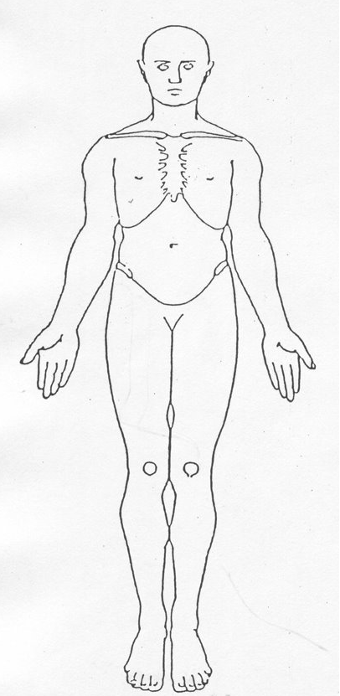  1  2  3 | 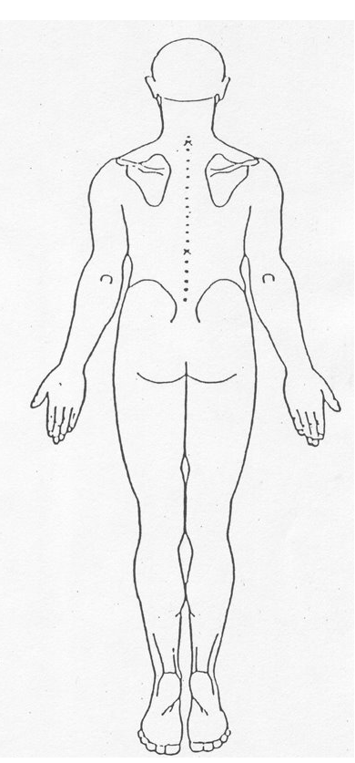  4  5  6

ABOUT THE PERSON(S) ALLEGEDLY RESPONSIBLE FOR THE ABUSE:
Unknown at present: |  |  | More than one alleged perpetrator? Yes / No (Add details to additional information box on next page)
Name: |  |  |  | Address:  Telephone:
DOB: | Age: |  |  | Relationship to Alleged Victim:
Perpetrator’s Employing Agencies: (List all known) |  |  |  |  |  | Volunteer? Yes / No
Is the alleged perpetrator an adult at risk? Yes / No / Don’t know

If the alleged perpetrator is an adult at risk, do they have capacity to understand their actions? Yes / No / Don’t know
Is alleged perpetrator a child?  Yes / No / Don’t know |  | Is alleged perpetrator aware of the referral? Yes / No / Don’t know |  |  | Is alleged perpetrator known to Social Services, Health or Police?

ABOUT THE PEOPLE WHO WITNESSED THE INCIDENT(S):
Name of Witness | Address, inc Post Code | Telephone no. | Relationship to victim (if any) | Is witness a child? | Is witness an adult at risk? |  | Is witness aware of referral?
WHO HAS RAISED THE CONCERN?
Name | Address, inc Post Code | Telephone no. | Relationship to victim (if any) | Occupation / Employer |  | When was the disclosure made
Does the reporter wish to remain anonymous? Yes / No
If yes, explain why: (excludes professionals)

ADDITIONAL INFORMATION:
VIEWS OF THE SUBJECT:
What are the views and wishes of the adult at risk? What would the adult at risk like as an outcome to this referral? What would they like to happen?

Guidance Notes

An “Adult at risk” is a person aged 18 years or over who
- Is experiencing or is at risk of abuse or neglect and
- Has a need for care and support and
- As a result of those needs is unable to protect himself against the abuse or neglect or the risk of it
Adults at risk may have or may lack mental capacity to make specific decisions. The Mental Capacity Act 2005 specifies that:
“A person lacks capacity in relation to a matter if at the material time he is unable to make a decision for himself in relation to the matter because of an impairment of, or a disturbance in the functioning of, the mind or brain”
A person is assumed to have capacity unless he/she is assessed as unable to do any one of the following:
- Understand the information relevant to the decision; or
- Retain information; or
- Use or weigh that information as part of the process of making the decision; or
- Communicate their decision (whether by talking, using sign language, writing etc)

NOTE: Be aware of information security when sharing or emailing this completed document and ensure you adhere to data protection principles and boundaries of confidentiality.

