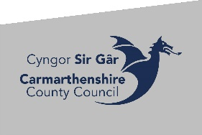 Carmarthenshire County Council
Notice of Section 25 Community Review

Notice is hereby given that in accordance with Section 25 of the Local Government (Democracy) (Wales) Act 2013 (the Act), Carmarthenshire County Council (the Council) is to carry out a review of the community boundaries between Llanboidy Community Council and Whitland Community Council, in particular where the community boundaries meet at the point of the field that is home to Whitland Abbey ruins.

The current arrangements can be found on the Council’s website: Elections & Voting (gov.wales) together with the Terms of Reference or can be inspected at: Electoral Services, Block 4, Parc Myrddin, Richmond Terrace, Carmarthen, SA31 1HQ.

Electors within the Council area or within a UK Parliamentary constituency may make a representation to the initial consultation. This consultation opens from Monday 16 December and ends on Monday 27 January 2025. Following on from this, all submissions will be considered and will help to formulate the Draft proposals after which there will be a further 6-week consultation period. Again, all submissions will be considered and will help formulate the Final proposals.
Comments and representations may be submitted as follows:
By post | Electoral Services, Block 4, Parc Myrddin, Richmond Terrace, Carmarthen, SA31 1HQ
By email | ElectoralServices@carmarthenshire.gov.uk

All representations to the initial consultation must be made between 16 December 2024 and by no later than 27 January 2025
All representations to the draft consultation must be made between14 April 2025 and by no later than26 May 2025

