CARMARTHENSHIRE
REVISED LOCAL DEVELOPMENT PLAN (2018-2033)
EXAMINATION

Hearing Session 13 – Additional Sites Additional Sites (Clusters 1 - Carmarthen and 2 - Llanelli)
Action Point | Council Response | Inspector’s Comments
AP13/1 – Council to provide a plan showing the boundary of the Grade 3a agricultural land within additional site ref PrC1/(iv). | The following plan shows the additional site PrC1(iv) with the Predictive Agricultural land grading overlain (key is set out below)  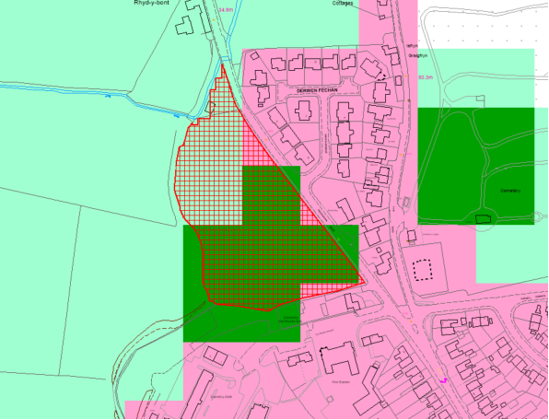  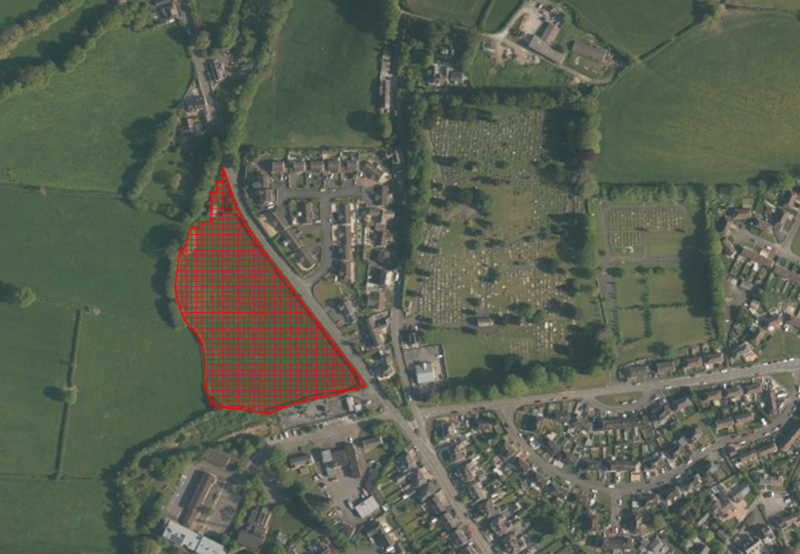  The map above illustrates the predictive agricultural land classification for additional site PrC1(iv), which is outlined in red and shown with red hatching.  - Grade 3a (Best and Most Versatile Land) – The areas shown in dark green represent Grade 3a agricultural land.  - Grade 3b – The areas shaded in light green indicate Grade 3b agricultural land.  - Grade U – Land shown in pink is classified as Grade U (urban/non-agricultural land).  Whilst it is recognised that a part of the site is identified as Grade 3a predicted BMV agricultural land, it is acknowledged that, by its very nature, the ALC Map for Wales is a predictive mapping exercise. In this respect it should be noted that the component of the site identified as containing Grade 3a agricultural land, is isolated from any other high grade agricultural land and surrounded by grade 3b and urban land.  As such it was not considered to have a notable bearing on the suitability of the site.  The above aerial view provides additional contextual clarity in relation to the identification of the cemetery to the West of the site as grade 3a. This highlights that by its very nature, the ALC Map for Wales is a predictive mapping exercise.  The additional site is located within a sustainable location identified as a primary centre within the Revised LDP and lies adjacent to existing built form to the east and south. Its development would result in a sustainable development and represent logical rounding off at this part of the settlement.  The portion of land identified as grade 3a totals less than 1ha in area and on balance it is considered that the site presents an opportunity for sustainable development at the edge of one of the County’s largest settlements consistent with the strategy of the Plan and the settlement hierarchy | Agreed.
AP13/2 – Council to provide viability information in respect of additional site ref SeC6/(ii). | We have been informed by the Development Management Officer (DMO) that Andrew Burrows (Burrows Hutchinson) is currently assessing the revised viability appraisal that has been submitted by the landowner/applicant to account for a lesser contribution towards affordable housing (that they argued is required to make the development viable).  We note the sensitivities regarding the values and costs set out within the appraisal which remains pending. The Council will pass on a summary of Andrew Burrows’ assessment of the revised viability as soon as this has been received (and this may be subject to approval by the applicant at this stage of the planning application process). The Development Management case officer has clarified that planning approval will follow if Andrew Burrows review endorses with the revised viability assessment subject to the consideration of the application in light of the NRW interim guidance of the marine SAC. | Noted.
AP13/3 – Council to provide a plan showing the boundary of the Development High Risk Area within additional site ref SeC7/(i). | The following plan identifies the additional site SeC7/(i) with the Coal Authority development high risk area overlain (in grey).  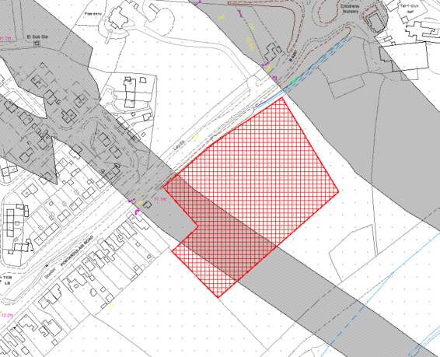  A small part of the site is identified as a development high risk area by the Coal Authority. In such cases, it is standard practice for a Coal Mining Risk Assessment (CMRA) to be required to support a planning application. The assessment will demonstrate that potential mining-related risks have been thoroughly considered and managed to ensure the safety and stability of the development.  These potential risks include:  - Mine Entries: Old shafts and adits that pose a risk to surface stability.  - Shallow Coal Workings: Both recorded and probable shallow workings near the surface.  - Mine entries (shafts and adits).  - Recorded Mine Gas Sites: Areas where coal mining gases might accumulate.  - Recorded Coal Mining Related Hazards: Specific hazards identified in the Coal Authority's records, including fissures and breaklines.  - Former Surface Mining Sites: Old opencast mining areas and associated high walls.  Mitigation measures will need to be employed if any features are discovered on the site. It is not envisaged that this will be an impediment to the delivery of the site as proposed for inclusion in the Revised LDP. | Agreed.

