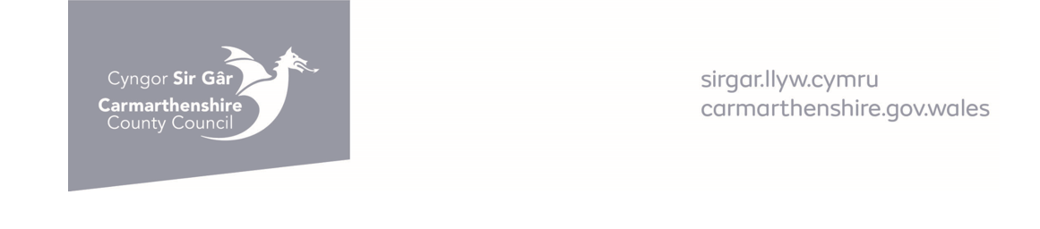
RE: PROVISION OF PRIVATE ACCESS PROTECTION MARKINGS
Thank you for your request for a private access protection marking. Due to increasing demands, the following criteria for their provision now apply:-

- The white bar marking is reserved for those sites where there is a persistent problem, with frequent obstruction of an access.

- The lines are intended to deter drivers who would otherwise park across an access. Therefore they can be placed in residential streets with a high parking demand by non-residents e.g. near shopping or commercial areas. They will not be used where parking obstruction is by neighbours.

- They shall be laid in accordance with the Road Marking Regulations and in white non-reflective material.

- It should be noted that these markings have no legal standing. However if a vehicle does park on them, the presence of the line would tend to support the offence of obstruction.

- A site visit will be conducted on receipt of your initial application. Please do not send any payment whilst investigations are ongoing. Once the investigation has been completed a Traffic Management Officer will contact you to confirm if your application has been successful or not.

- Charges varies depending on the size of the required road marking:-

£220 + VAT (length up to 7 metres) TOTAL COST £264
£250 + VAT (length over 7 metres) TOTAL COST £300

Once approval of the marking is received payments can be made either by:--
Telephoning Carmarthen’s Cashiers line for payment by debit/credit card on:- 01267 228686
For Direct Cash payments please visit our Cash Offices at Ty Elwyn, Llanelli or Spillman Street, Carmarthen

If sending a cheque or postal order made payable to Carmarthenshire County Council to the address below.
Cheque Number ……………………. Please tick if receipt is required:-

Your Home Address:- | Please return your completed form by email to  ENTrafficManagement@Carmarthenshire.gov.uk  Or by post to:-  Traffic Management section,  Carmarthenshire County Council,  Department of Place & Infrastructure  Highways and Transport,  Parc Myrddin, Block 2  Richmond Terrace  Carmarthen  SA31 1HQ
Home Telephone: | Your Email address:-
Signed:  Dated:- | (Name in Capitals)

