Scrutiny Topic Suggestion Form

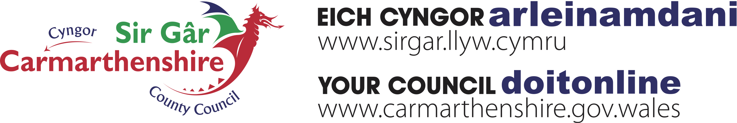If you think there is an issue that Scrutiny should look at, then let us know. You can suggest a topic for review or inclusion on one of our Scrutiny Committee Forward Work Programmes by emailing us at [Scrutiny@carmarthenshire.gov.uk](mailto:Scrutiny@carmarthenshire.gov.uk) or completing the following form and returning to us at:-

Democratic Services Unit, Chief Executive’s Department, Carmarthenshire County Council, County Hall, Carmarthen. SA31 1Jp.

|  |  |
| --- | --- |
| Your Name |  |
| Your Address |  |
| Telephone No. |  |
| Email Address |  |
| Suggested Topic for Scrutiny  Consideration |  |
| Please explain why feel this issue should be reviewed |  |
| What do you think are the potential benefits and outcomes from undertaking a review of this topic? |  |
| Do you have any further comments that you wish to make in support of your suggested topic? |  |