CARMARTHENSHIRE
REVISED LOCAL DEVELOPMENT PLAN (2018-2033)
EXAMINATION

Hearing Session 4 – Prosperous People and Places – Employment, the Visitor Economy and Infrastructure

Tuesday, 22 October 2024 between 10:00 and 17:00

Action Point | Council Response / Proposed MAC | Inspectors’ Comments
AP4/1 | Amend Policy SP7 as follows:  Strategic Policy – SP 7: Employment and the Economy  Sufficient Land has been allocated for the provision of 71.21 hectares of employment provision for the Plan period in accordance with the Plan’s Settlement Framework (Policy SP3) and sustainability principles.  The sustainable approach to the provision of employment land reflects the following:  1) a) The allocation and delivery of:  a) 1. Pentre Awel, Llanelli and  b) 2. Yr Egin – Creative Digital Cluster, Carmarthen;  2. b) Allocating employment land in sustainable location which accords with the sustainability principles of the Plan;  3. c) Safeguard existing employment sites – recognising their contribution as part of the employment portfolio in meeting ongoing need;  4. d) Supporting small scale sustainable employment developments and enterprises in lower tiered settlements.  5. e) Ensuring support is provided to entrepreneurship as part of the creation of a diverse and growing economy;  6. f) Allow appropriate small scale employment opportunities and rural enterprises in the countryside to support rural communities and to deliver a diverse and sustainable rural economy.  Insert new paragraph relating to Pentre Awel before paragraph 11.140.  In considering the allocation and delivery of employment land within Pentre Awel, not all employment activities relate to B class uses and consequently it does not form part of the 71.21ha of employment land provision set out in Policy SP7.  Deletion of paragraphs 11.142 – 11.145 with the inclusion of the new reasoned justification  11.142 The Council has undertaken evidence gathering to provide an understanding of the future employment need notably around the Welsh Government’s nine priority sectors.56 Further evidence has been prepared in conjunction with Pembrokeshire County Council to establish quantitative analysis of forecast demand for employment sites at the larger than local level. This Two County Study was supplemented by market and employer evidence in relation to market demand. In addition, work has been undertaken in relation to the links between equating the levels of employment land and jobs with the requirement for new homes growth for the County.  11.143 The Two County Study seeks to achieve a balance between fulfilling the requirements of Technical Advice Note 23 on Economic Development (February 2014), whilst placing a strong emphasis on flexibility, realism of sector growth and ability to meet demand at a regional scale.  11.144 TAN 23 considers that ‘land provision targets may be higher than anticipated demand, to allow for the chance to meet demand. The Practice Guidance to the TAN (August 2015) considers that, where justified, land provision targets maybe higher than anticipated demand, to allow for the chance that the assessments are too low and to ensure that no opportunities are missed. In acknowledging the importance of not solely relying on employment forecasts when identifying a portfolio of employment land, the Two County Study emphasises the demand and confidence of indigenous businesses to remain and grow, and a desire by stakeholders to preserve locational advantages and strategic assets for future growth.  11.145 In recognition of the above, the Two County Study has identified a portfolio of sites within the study area which are considered to offer strategic benefits and opportunity for growth and job creation.  Evidence for future employment need  The Council has undertaken evidence gathering to provide an understanding of the future employment need within the County and notably around the Welsh Government’s nine priority sectors. Two pieces of evidence have been produced which include the Housing and Economic Growth Report (November 2022), and a Two Counties Study which has been prepared in conjunction with Pembrokeshire County Council.  Strategic Policy SP7: Employment and the Economy sets the framework to enable the delivery of a balanced level of employment land to accommodate the new jobs and identified need through the Two County Economic Study for Pembrokeshire and Carmarthenshire and the Housing and Economic Growth Report.  The Two County Study established quantitative analysis of forecast demand for employment sites at the larger than local level and was supplemented by market and employer evidence in relation to market demand. The Housing and Economic Growth Study further considered the links between equating the levels of employment land and jobs with the requirement for new homes growth for the County.  The Revised LDP’s background evidence provides the narrative for the relationship between Housing growth, Job creation and employment land provision. In extrapolating data from the demographical modelling, it suggests that the preferred scenario of 8,822 dwellings could accommodate 276 new jobs per year, which would not support fully the Experian forecast of 354 jobs per year. To achieve this, it would require a more pronounced labour force behavioural change within the County; however, the Plan seeks to consider several factors in determining a level of sustainable growth.  The WG’s Practice Guidance - Building an Economic Development Evidence Base to Support a Local Development Plan considers that where justified, land provision targets may be higher than anticipated demand, to allow for the chance that the assessments are too low and to ensure that no opportunities are missed. They should also allow for flexibility, competition, and choice. However, persistent oversupply of employment land may cause harm where the planned land supply exceeds demand, so that allocated employment sites remain vacant for long periods and frustrate development for other land uses.  The Revised LDP allocates 71.21 hectares of employment land which could provide an estimated 6,652 jobs, and whilst it is recognised that the homes to jobs calculation, and job creation to employment land provision does not align with the Revised LDP it must be noted that there is not an exact and direct relationship between housing and jobs, and thus any relationship can only be read as indicative.  It is also important to note that the level of new homes must be deliverable and evidenced. In this regard any increase in new homes to correspond with the potential jobs created through new employment allocations would result in an undeliverable over-provision of new housing within the County.  Nevertheless, the Housing and Economic Growth Report assessed the patterns of commuting from the 2011 Census which identified a commuting ratio of 1.09, indicating a net outflow of commuters from Carmarthenshire. The Plan, through the allocation of 71.21ha, seeks to re-balance the commuting ratio to reduce the outflow of Carmarthenshire’s residents to work and to promote investment and sustainable forms of growth within the County.  The scale of employment land identified within the Plan ensures flexibility and deliverability and reflects the analysis set out within the Two County Study and the Housing and Economic Growth report. Its importance is to support the investment and ambition of Carmarthenshire’s strategic regeneration plan and other economic growth strategies as well as the Swansea Bay City Deal and South West Wales Regional Economic Delivery.  The Housing and Economic Growth Report assessed the patterns of commuting from the 2011 Census which identified a commuting ratio of 1.09, indicating a net out-commute. The Plan, through the allocation of 71.21ha, seeks to re-balance the commuting ratio to reduce the outflow of Carmarthenshire’s residents to work and to promote investment and sustainable forms of growth within the County. | Subject to the suggested amendments the change is agreed.
AP4/1 | Insert new paragraph before 11.142  New Paragraph Number: Further evidence has been produced in the Housing and Economic Growth Report (November 2022). The Report considers the potential for further economic growth in Carmarthenshire over the new plan period to 2033 with the Experian forecast providing the preferred assumptions. The ten-year rebased demographic projection supported within the Plan (276 jobs per annum) is more closely aligned with the level of job growth forecast by Experian (354 jobs). The Experian baseline forecasts can also be adjusted to account for known and/ or plausible investments and offers the potential to support the investment and ambition of Carmarthenshire’s strategic regeneration plan and other economic growth strategies, which reflects for an investment led growth scenario of 674 jobs per annum to 2033. | Change agreed.
AP4/2 | New column added to table 7 below which indicates the amount of committed employment land.  N.B. there is a minor error in the ELR 2023 which relates to the overall committed figure in the study. The figure within Table 7 below is the correct figure and this will be updated in the next ELR update.  Consequential amendment to Table 6 as a result of the updated figures in Table 7.  Amend Policy EME3 as follows, with the subsequent deletion of paragraph 11.161 of the reasoned justification.  EME3: Employment Proposals on Allocated Sites  Proposals for B1, B2 and B8 employment development will be permitted on the following allocated employment sites where they comply with the proposed use of the site.  Where it can be demonstrated, oOther employment and related ancillary non-B class uses will be permitted on allocated employment sites where it can be demonstrated the proposed development complements and enhances the site’s role as identified in the Employment Site Allocation table below. Consideration must be given to the amenity and the safe operation of adjacent employment uses to avoid conflict between different land uses.  A. LDP Alloc B. Completed C. Completed but not forming part of allocated figure.¹ D. Committed E. Residual Supply  (A-B-D=E)  PC1 - Carmarthen 18.687 0 0 3.93 14.757  PC2 - Llanelli 17.489 0 0 1.90 15.589  PC3 – Ammanford / Cross Hands 28.118 9.52 18.598  Service Centres 6.916 3.891 3.025  Sustainable Villages 0 0 0 0 0  Rural Villages 0 0 0 0 0  Total 71.21 19.24 51.97  Table 6: Employment Land Provision  Site Ref: Site Name: Location: Use Class: Total Area (Ha): Amount Committed (Ha)  PrC1/E1 Cillefwr Industrial Estate Carmarthen B1, B2, B8 4.167 0.56  PrC1/E1 (i) Land west of Cillefwr Road West 2 0  PrC1/E1 (ii) Land north of Alltycnap Road 1.215 0  PrC1/E1 (iii) Land south of Alltycnap Road 0.952 0.56  PrC1/MU1 West Carmarthen Carmarthen B1, B2, B8 4.53 0  PrC1/MU2 Pibwrlwyd Carmarthen B1,B2, B8 8.95 2.33  PrC1/SS1 Yr Egin Carmarthen B2 1.04 1.04  PrC2/E2 Dafen Llanelli B1,B2,B8 17.489 1.9  PrC2/E2 (i) Land east of Calsonic 4.723 0  PrC2/E2 (ii) Land west of Gestamp Tallent 1.547 0  PrC2/E2 (iii) Land at Heol Aur 1.657 0  PrC2/E2(iv) Land west of Heol Gors 1.449 0  PrC2/E2 (v) Land at Heol Croppin 0.355 0  PrC2/E2 (vi) Land west of the Beacon 1.881 1.9  PrC2/E2 (vii) Land east of Air ambulance Base 1.316 0  PrC2/E2 (viii) Land at Llanelli Gate, off Heol Aur 3.755 0  PrC2/E2 (ix) Land west of Llys Aur 0.806 0  PrC3/E1 Cross Hands East Ammanford / Cross Hands B1,B8 8.31 8.31  PrC3/E2 Cross Hands West Food Park Ammanford / Cross Hands B1,B2,B8 5.647 0  PrC3/E2(i) Land west of Castell Howell 1 0  PrC3/E2(ii) Land south of Heol Parc Mawr 2.712 0  PrC3/E2(iii) Land north of Dunbia 1.935 0  PrC3/E3 Cross Hands Business Park Ammanford / Cross Hands B1,B2,B8 4.76 0  PrC3/E3 (i) Heol Stanllyd (West) 2 0  PrC3/E3 (ii) Heol Stanllyd (South) 2.156 0  PrC3/E3 (iii) Heol Stanllyd (East) 0.604 0  PrC3/E6 Capel Hendre Industrial Estate Ammanford / Cross Hands B1,B2,B8 0.538 0.44  PrC3/E7 Parc Hendre, Capel Hendre¹ Ammanford / Cross Hands B1,B2,B8 8.112 0.77  PrC3/E7(i) Parc Hendre (West) 2.165 0  PrC3/E7(ii) Parc Hendre (North) 1.955 0  PrC3/E7(iii) Parc Hendre (East) 1.05 0.77  PrC3/E7(iv) Parc Hendre (South) 2.942 0  PrC3/E8 Cilyrychen Industrial Estate Cilyrychen B1,B2,B8 0.751 0  SeC4/E1 Dyfatty Burry Port B1,B2,B8 3.036 3.036  SeC16/E1 Beechwood Industrial Estate Llandeilo / Rhosmaen B1,B2,B8 0.289 0.25  SeC16/MU1 Beechwood Llandeilo / Rhosmaen B1,B2,B8 0.755 0  SeC16/E2 Former Market Hall Llandeilo B1 0.2 0.2  SeC18/E1 St Clears Business Park St Clears B1,B8 0.421 0  SeC19/E1 Whitland Industrial Estate Whitland B1,B8 0.489 0  SeC19/E2 Land South of Former Creamery Whitland B1,B2,B8 1.321 0  SeC13/E1 Old Foundry Llanybydder B1,B8 0.405 0.405  Total 71.21 19.24  Table 7: Employment Proposals on Allocated Sites  11.160 The total figure in the above table includes notional figures for B use employment on Mixed Use sites (Policy SG1) and Strategic sites (Policy SP6). The Table identifies committed land within each site (source: Employment Land Review, 2023).  11.161 Where appropriate, other employment and related ancillary non-B class uses will be permitted on allocated employment sites where the proposed development complements and enhances the site's role as identified in the Employment Site Allocation table. Consideration must be given to the amenity and the safe operation of adjacent employment uses to avoid conflict between different land uses. | Changes agreed.
AP4/2 | Reference is made to Appendix 1 below which considers a new schedule in the Plan appendices. | Subject to the suggested amendments the schedule is agreed.
AP4/3 | Reference is made to Appendix 2 below which provides a schedule of existing employment sites, including new site reference for clarity.  Reference is also drawn to a number of additional existing employment sites which have been previously excluded from the Proposals Maps. These sites will be identified and delineated through the Matters Arising Changes (Maps) consultation with consequential amendments to the next iteration of the Employment Land Review. | Changes agreed.
AP4/3 | EME1: Employment- Safeguarding of Employment Sites  Sites identified for employment purposes through policy SP7 and existing employment sites will be safeguarded for such uses (B1, B2, B8 and those identified through relevant policy provisions).  Exceptionally, pProposals which result in their loss will only be permitted where it can be demonstrated that:  - The site or premises is no longer required or suitable for employment use;  - The proposed use could not reasonably be located elsewhere in accordance with the policies of this Plan;  - There is sufficient quantity, quality and variety of employment land or premises that can be brought forward to meet the employment needs of the County and the local area;  - There are no economically viable industrial or business employment uses for the site and premises;  - An employment use is incompatible with adjoining/surrounding uses; and  - Where applicable the proposed uses are complimentary to the primary employment use of the surrounding area and will not cause an unacceptable impact on the operations of existing businesses.  Amend paragraph 11.153 as follows:  11.153 This policy seeks to ensure that existing employment sites are protected from alternative (non-B class) uses. In order to maintain an adequate supply of employment land which provides for a range and choice of potential uses, this policy seeks to protect defined employment areas from non-employment uses which should be in better and potentially more appropriate locations. Proposals for alternative (non-B) uses will need to justify why the site or premises is no longer required (for economic reasons) or suitable (become inappropriate for the location) for employment use. In terms of economic reasons, in the absence of an alternative provision, proposals resulting in the loss of an employment use will only be permitted where it can be demonstrated that business uses are no longer viable at the site. This must may include evidence to show that appropriate and reasonable efforts have been made to market the site for sale or lease for its existing, or similar, employment use. The type of information must include the following:  - The length of time the site or property has been vacant; and,  - A Marketing Strategy detailing the type of use which the site/property has been marketed for and its duration – there must be a minimum of 12 months appropriate marketing; and  - The amount of interest in the site during the marketing period, including the type and number of queries, together with the reason(s) for the ultimate lack of take-up/interest.  The type of evidence required will depend upon individual circumstances but should include details of why the site or business is no longer appropriate at this location, or in use.  Insert new paragraph before 11.154.  New paragraph: Where a proposal seeks a change of use to B1(a) office use on a safeguarded employment site, reference to the town centre first approach as set out in national policy should be considered. Particular regard should be had to Policy 6: Town Centre First as set out in Future Wales: the National Plan 2040, and paragraph 4.3.18 of PPW which relates to the sequential approach when determining planning applications for retail and B1 uses.  11.154 In recognition of the pressures on employment areas from alternative uses (non-Class B), the policy accepts that some flexibility may in some instances be required. Such uses are often partial B class uses combining a small-scale retail element with predominantly business, industrial or storage use, or are sui generis. It is also accepted that in meeting the needs of such uses, employment areas are often likely to be more acceptable than other locations such as residential areas, or even town centres. Any retail element will be expected to be ancillary to the primary use, and for trade purposes as opposed to the public. | Subject to the suggested amendments the changes are agreed.
AP4/4 | Amend Policy EME2 as follows  EME2: Employment – Extensions and Intensification  Proposals for extensions (of existing employment buildings) and/or intensification of existing employment enterprises will be permitted provided that:  a) The development proposals are will not likely to cause environmental damage or prejudice other redevelopment proposals;  b) The proposal does not extend and/or intensify a use or activity that might result in adverse amenity issues, or may not be compatible, with neighbouring uses; and  c) The development proposals are is of an appropriate scale and form compatible with its location.  Proposals for the expansion of existing rural enterprises will be supported subject to the above provisions and the policies and proposals of this Plan.  Amend paragraph 11.157 as follows  11.157 This policy relates to extensions to existing buildings and/or the intensification of uses on existing employment enterprises, in both rural and urban locations. The intensification of existing employment enterprises may include the small-scale extension of the existing site, and which may include new buildings associated with the extension, if these are considered necessary to the operation. However, Pproposals which seek to extend and/or intensify a use or activity will not be favourably considered if they are not compatible with surrounding uses, or likely to result in adverse amenity issues which would prejudice other redevelopment proposals. | Subject to the suggested amendments the changes are agreed.
AP4/5 | Amend Policy EME4 as follows:  EME4: Employment Proposals on Non-Allocated Sites  Proposals for employment development on non-allocated sites, but within the development limits of a defined settlement (Tiers 1-3 as defined within Policy SP3) will be permitted where:  - it is demonstrated that no other suitable existing or allocated employment sites or previously developed land can reasonably accommodate the proposal;  - the development proposals are of an appropriate scale and form, and are not detrimental to the respective character and appearance of the townscape/ landscape; and  - The development is compatible with its location and with neighbouring uses.  Employment proposals outside the development limits of a defined settlement (Tiers 1-3),(Policy SP3) within Tier 4 settlements, or in the open countryside, will be permitted where it either satisfies criteria d and f, or e and f below:  - The proposal is directly related to a settlement or hamlet listed in Policy SP3; or  - The proposal is supported by a business case which demonstrates that its location is justified; and  - The proposal is of an appropriate scale, size and design.  New paragraph following 11.164 with the following with the addition of the sentence below  11.164 Within the development limits of a defined settlements, the policy requires proposals to demonstrate their locational requirement through a sequential approach to site selection. In the first instance, they must look to proposed and existing allocations to cater for employment need. Only then should non-allocated sites be considered.  New paragraph: In relation to the application of a sequential approach for the siting of B1(a) office uses, reference to the town centre first approach as set out in national policy should be followed. Particular reference is made to Policy 6: Town Centre First as set out in Future Wales: the National Plan 2040 and paragraph 4.3.18 of PPW which relates to the sequential approach when determining planning applications for retail and B1 uses.  Amend paragraph 11.165, as follows:  11.165 For proposals outside the development limits of a defined settlement (Tiers 1-3), and those settlements identified as rural villages (Tier 4) they must show that they are directly related to a settlement listed in Policy SP3. or hamlet, or In the case of an open countryside location which is not directly related to a settlement, proposals must be supported by a business case which justifies its location. ‘Directly related’ is defined in the glossary. The Plan recognises that small-scale enterprises have a vital role to play in the rural economy and contribute to both local and national competitiveness and prosperity. Many commercial and light manufacturing activities can be appropriately located in rural areas without causing unacceptable disturbance or other adverse effects. In this respect, the development of small businesses would address any local need for employment accommodation. | Subject to the suggested amendment the changes are agreed.
AP4/6 | Amend Policy SP11 as follows:  Strategic Policy – SP 11: The Visitor Economy  Proposals for tourism and visitor economy related developments will be supported where they:  - exhibit high quality design and placemaking principles;  - contribute to the protection and enhancement of the natural environment;  - add value to our visitor economy, and;  - are sustainably and appropriately located. | Change agreed.
AP4/7 | Amend Policy VE1 as follows:  VE1: Visitor Attractions and Facilities  - Proposals for high quality visitor attractions and facilities, including appropriate extensions to existing facilities will be permitted, where they are located within, or directly related to a defined settlement (Policy SP3).  - All other proposals for high quality visitor attractions and facilities not considered under Point 1 above located within, or directly related to a defined settlement (Policy SP3) will be permitted, where it can be demonstrated that the proposal accords with national planning policy.  - they are demonstrably reliant clearly rely on the specific attributes of the site / open countryside location; or  - Proposals should It is demonstrated that the following sequential approach has been undertaken where  - the adaptation and re-use of an existing building has been considered in the first instance;  - then previously developed land;  - then a greenfield location.  All proposals should reflect and respect the role and function of the area, as well as its sense of place, most notably in terms of scale, type, character, design, layout and appearance.  Where appropriate, p Proposals should be accessible by various modes of transport - especially sustainable modes of transport - such as walking, cycling and public transport. | Subject to the suggested amendment the change is agreed.
AP4/8 | Amend Policy VE2 as follows:  VE2: Holiday Accommodation  1. a) Proposals for high quality serviced and self-catering accommodation, including appropriate extensions to existing accommodation, will be permitted where they are located within, or directly related to a defined settlement (Policy SP3).  2. b) Proposals for high quality serviced and self-catering accommodation that are located outside of the above locations of or are not directly related to a defined settlement (Policy SP3) will only be permitted where they consist of the re-use and adaptation (including conversion) of existing buildings in conjunction with pPolicy RD4 RD2.  All proposals set out above should reflect and respect the role and function and sense of place of the area, most notably in terms of scale, type, character, design, layout and appearance - as well as those uses already located in the vicinity of the site. | Subject to the suggested amendments the changes are agreed.
AP4/9 | This Action Point is a repeat of AP4/8
AP4/10 | Criterion b of Policy VE3 has been amended to reflect the fact that the mention of proposals not resulting in an excessive area of hardstanding is already in paragraph 11.254 of the reasoned justification.  VE3: Touring Caravan, Camping and Non - Permanent Alternative Camping Accommodation  Proposals for new touring caravan, camping and non-permanent alternative camping accommodation sites, and for as well as extensions, improvements or the intensification of existing sites, will be permitted where they reflect and respect the role and function and sense of place of the area, as well as the following:  - they are of high quality in terms of design, layout and appearance, and will not have an unacceptable adverse effect upon the surrounding landscape, seascape and/or townscape;  - they will not result in an excessive area of hard standing, and the accommodation units can easily readily be removed from the site;  - they will not result in an over concentration of sites within the area;  - they are suitably located in relation to the main highway network and adequate access can be provided without detriment to the natural and built environment;  - the accommodation is used for touring purposes only, with occupation limited to holiday use.  Proposals which include a need for ancillary structures should demonstrate that a sequential approach has been considered, commencing with the re-use of existing buildings, followed by the need to construct new buildings.  New buildings will only be permitted where they are appropriate in terms of their siting, need and scale.  ---------------------------------------------------------------------------------------------------------  The following is to be added as a new paragraph between paragraph 11.254 and paragraph 11.255  The term "over concentration" in the context of this Policy refers to the proliferation of touring caravans, camping, and alternative non-permanent camping sites leading to adverse impacts on the character, function, and amenity of the locality. The number and density of similar facilities in the area should be considered as well as their pattern of distribution and whether the cumulative visual or environmental impacts detracts from the landscape, seascape or townscape character. | Subject to the suggested amendment the changes are agreed.
AP4/11 | Amend Policy VE4 as follows:  VE4: Static Caravan and Chalet Sites and Permanent Alternative Camping Accommodation.  a) Proposals for new Static Caravan and Chalet Sites will be permitted where:  - a) they are within or directly related to a defined settlement (Policy SP3), or, they are located or demonstrate a spatial and functional relationship with a relevant existing tourism facility or attraction;  - b) they are of high quality in terms of design, layout and appearance, and will not have an unacceptable adverse effect upon the surrounding landscape and/or townscape; and  - c) they will not lead to a significant and unacceptable intensification in the provision of sites in the locality;  b) Proposals for the enhancement and extension of existing sites will be permitted where:  - d)it will increase the vitality, sustainability and environmental quality of the site;  - e) it will not result in an unacceptable increase in the density of units and/or the overall scale of the site  - f) it will not have an unacceptable harm on the surrounding landscape, seascape and / or townscape; and  - g) it provides (where appropriate) for the significant improvement of the overall quality, appearance and setting of the site. | Changes agreed.
AP4/12 | Amend Policy RD5 as follows:  RD5: Equestrian Facilities  Development proposals for stabling, equestrian facilities or use of land for equestrian activities will be permitted where:  - the facility is grouped within an existing farm complex, or is sited as close as possible to existing buildings;  - the proposed use will be of a scale and nature an intensity appropriate to its environment and setting;  - the development will not have an adverse impact on the landscape or nature conservation interests; and  - suitable access and parking can be provided for horse boxes and the proposed the level of commercial activity; and  - commercial facilities have suitable access to the highway network. | Subject to the suggested amendments the changes are agreed.
AP4/13 | Amend Policy INF3 as follows:  INF3: Broadband and Telecommunications  The Council will work with the telecommunications industry and the communications regulator Ofcom to maximise access to reliable super-fast broadband, wireless hotspots and improved mobile availability for all residents and businesses, assisting them (where appropriate) in delivering their investment plans to address any infrastructure deficiencies.  New developments should include the provision of Gigabit capable broadband infrastructure from the outset.  New major developments must be served by a high speed and reliable broadband connection to the premises.  Smaller developments should provide access to the most viable high-speed connection as well as additional ducting for future Fibre to the Premises (FTTP) or other provision.  Exceptions will be made where applicants have shown through consultation with broadband infrastructure providers, that this would not be possible, practical or economically viable. In such cases, an equivalent developer contribution towards off-site works may be sought which could enable greater future access.  Amend the reasoned justification to policy INF3 to include the following new paragraph after 11.198.  The Council Planning authorities will work with the telecommunications industry and the communications regulator Ofcom to maximise access to reliable super-fast broadband, wireless hotspots and improved mobile availability for all residents and businesses, assisting them (where appropriate) in delivering their investment plans to address any infrastructure deficiencies.  Amend paragraph 11.201 to read as follows:  The policy also recognises that in a small proportion of cases, broadband will not be able to be provided to new developments due to their very rural location. The policy therefore includes the potential to provide a sum of money to contribute towards an alternative solution. Such exceptions will be made where applicants have shown through consultation with broadband infrastructure providers, that this would not be possible, practical or economically viable. In such cases, an equivalent developer contribution towards off-site works may be sought which could enable greater future access. However, wherever possible the solution should include the development making necessary provision for on-site infrastructure to facilitate the improvements. | Changes agreed.
AP4/14 | The following amendment to be made to criteria a) of Strategic Policy - SP2: Retail and Town Centres  - Proposals for retail and other appropriate town centre uses within the Carmarthen town centre boundary (including leisure, civic, cultural, education, business (including B1(a) offices), health and residential (on upper floors)) which support the growth of Carmarthen as a sub-regional retail town centre will be permitted where they maintain and enhance the vitality, viability and attractiveness of Carmarthen Town Centre. | Change agreed.

Appendix 1 –
Action Point AP4/2
New Appendix – Employment Allocations (Policy EME3)
Cluster 1
Site Ref. / Site Name | PrC1/E1 - Cillefwr Industrial Estate
Site Size (ha) | 4.167ha
Site Description | The site is located within and adjacent to an existing employment site at Cillefwr Industrial Estate and comprises relatively flat areas of vacant pasture land. Its size and scale allow the opportunity for small - medium scale development. For ease of identification, the site has been split into three separate elements as identified on the Revised LDP proposals map and in Policy EME3. A small part of the site is committed, as identified in Table 7.
Flood Risk | A small part of the site has been identified as being located within Flood Map for Planning (FMfP) Flood Zone 2 (Rivers), and a minimal element Flood Zone 3 (Rivers).
Key Considerations and Constraints | Highways & Transport - The site has road infrastructure in place which makes it immediately available for development.  Land Ownership - Mix of public and private.  Utilities - Being located within and adjacent to Cillefwr Industrial Estate, the site benefits from readily available utilities.  Flooding – The site may require a Flood Consequences Assessment. The site’s design and layout will need to consider flood risk. The most recent flooding data will need to be considered at planning application stage.

Site Ref. / Site Name | PrC1/MU1 - West Carmarthen
Site Size (ha) | 4.53ha
Site Description | The wider site is allocated as a mixed-use site providing for a variety of uses including residential, new Primary School, amenity/recreation, employment and community facilities. An indicative figure of over 4 ha is set for employment uses. A Planning & Development Brief was adopted for the site in 2010, and development is taking place in accordance with it.
Flood Risk | Flood Zone 1 (Rivers & Sea).  A small part of the site falls within the zones 2 and 3 for surface water and small watercourses.
Key Considerations and Constraints | Highways & Transport - Since the adoption of the Planning and Development Brief in 2010, the link road has been completed and development (housing elements) has been completed on the southern side of the site.  Land Ownership - The area identified for employment is in private ownership.  Flooding - The site may require a Flood Consequences Assessment. The site’s design and layout will need to consider flood risk. The most recent flooding data will need to be considered at planning application stage.  Utilities - The area identified for employment uses is surrounded by existing development and therefore benefits from readily available utilities.

Site Ref. / Site Name | PrC2/MU2 - Pibwrlwyd, Carmarthen
Site Size (ha) | 8.95ha
Site Description | Situated at a strategic location in close proximity to the A48, this is a largely flat, slightly sloping in places, greenfield site, within an area dominated by employment, retail and educational facilities. A masterplan has been developed for the site and sets out a mix of potential uses, including residential, education and commercial uses consisting of offices and light industrial. The indicative area for employment related uses amounts to nearly 9 hectares. A small part of the site is committed, as identified in Table 7.
Flood Risk | Flood Zone 1 (Rivers & Sea).  A small part of the site falls within the zones 2 and 3 for surface water and small watercourses.
Key Considerations and Constraints | Highways & Transport - The site is strategically located close to the main A48 Trunk Road and road infrastructure is in place at the north end of the site, from where access can be gained to the remainder of the site.  Land Ownership - Private.  Utilities - The site benefits from readily available utilities that already service the developed area in the north of the site, as well as the existing Coleg Sir Gâr campus in the south.  Flooding – The site may require a Flood Consequences Assessment. The site’s design and layout will need to consider flood risk. The most recent flooding data will need to be considered at planning application stage.

Site Ref. / Site Name | PrC1/SS1 - Yr Egin, Carmarthen
Site Size (ha) | 1.04ha
Site Description | This committed site is situated opposite (to the north of) the college of Trinity Saint David, this site forms part of a larger strategic site, which includes education uses as well as employment. The employment element comprises 1.04 ha, part of which has already been developed for offices (Egin Phase 1). A further project (Egin Phase 2) is currently in the developmental stage. Yr Egin forms one of three strategic projects specific to Carmarthenshire arising from the Swansea Bay City Deal.
Flood Risk | Flood Zone 1 (Rivers & Sea).  A small part of the site falls within the zones 2 and 3 for surface water and small watercourses.
Key Considerations and Constraints | Highways & Transport - The site is strategically located to the west of the centre of Carmarthen from which it can be accessed via College road to the east, or from Job’s Well Road to the south.  Land Ownership - Private  Utilities - The site benefits from readily available utilities that already service the developed part of the site.  Flooding – The site may require a Flood Consequences Assessment. The site’s design and layout will need to consider flood risk. The most recent flooding data will need to be considered at planning application stage.

Site Ref. / Site Name | PrC2/E2 - Dafen, Llanelli
Site Size (ha) | 17.489ha
Site Description | The site is located within and adjacent to an existing employment area at Dafen in the north east part of Llanelli. Its size and scale allow the opportunity for small - medium scale development. The site comprises nine separate elements as identified on the Revised LDP proposals map and in Policy EME3. A small part of the site is committed, as identified in Table 7.
Flood Risk | The Flood Map for Planning (FMfP) identifies an element of the site as falling within Flood Zone Rivers (Zone 3). In addition, small portions of the site fall within the zones 2 and 3 for surface water and small watercourses.
Key Considerations and Constraints | Highways & Transport - The site is strategically located adjacent to the A4138 which links Llanelli with the M4. The site has road infrastructure in place which makes it immediately available for development.  Land Ownership - Private.  Flooding - The site may require a Flood Consequences Assessment. The site’s design and layout will need to consider flood risk. The most recent flooding data will need to be considered at planning application stage.  Utilities - The site benefits from readily available utilities that already service the existing employment operations that lie adjacent to each of the 9 elements that make up this site.

Site Ref. / Site Name | PrC3/E1 - Cross Hands East
Site Size (ha) | 8.31ha
Site Description | This committed site is the largest employment allocation within the Cross Hands area. It has planning permission and has been developed over 2 phases to provide infrastructure and create 17 plots. The site accommodates B class employment uses, however there is a focus on Energy & Environment, Advanced Manufacturing, Creative, Agri-Food technology and Financial & Professional sectors.
Flood Risk | Flood Zone 1 (Rivers & Sea).  Small parts of the site fall within the zones 2 and 3 for surface water and small watercourses.
Key Considerations and Constraints | Highways & Transport - The plots are accessed via spurs of 2 main estate roads running through the site which are adopted, directly connecting to the Cross Hands link road that enables access onto the east/west slips on the A48/M4, as well as the A483 Swansea to Manchester route, making the estate highly accessible.  Land Ownership - The site is in public ownership and is managed by the Cross Hands Joint Venture, a partnership between the County Council and Welsh Government.  Flooding - Whilst parts of the site lie within the above flood zones, the site is the subject of a fully implementable planning permission. Furthermore, employment related activities are classed as less vulnerable development within TAN15.  Utilities - Infrastructure requirements have been addressed via the 2 phased infrastructure investment now completed.

Site Ref. / Site Name | PrC3/E2 - Cross Hands West Food Park
Site Size (ha) | 5.647ha
Site Description | The site is located within the existing built form in an area which is characterised by employment uses in Cross Hands. It comprises three separate elements as identified on the Revised LDP proposals map and in Policy EME3. Its size and scale allow the opportunity for development associated with traditional B class employment uses, in particular food production.
Flood Risk | Flood Zone 1 (Rivers & Sea).  A small part of the site fall within the zones 2 for surface water and small watercourses.
Key Considerations and Constraints | Highways & Transport - The site has road infrastructure in place which makes the site immediately available for development.  Land Ownership - Private.  Flooding - The site may require a Flood Consequences Assessment. The site’s design and layout will need to consider flood risk. The most recent flooding data will need to be considered at planning application stage.  Utilities - The site benefits from readily available utilities that already service the existing employment operations that lie adjacent to each of the three elements that make up this site.

Site Ref. / Site Name | PrC3/E3 - Cross Hands Business Park
Site Size (ha) | 4.76ha
Site Description | The site comprises three separate elements, as identified on the Revised LDP proposals map and in Policy EME3 and is surrounded by existing employment and retail uses, making it a logical location for related employment uses.
Flood Risk | Flood Zone 1 (Rivers & Sea).  Small parts of the site fall within the zones 2 and 3 for surface water and small watercourses.
Key Considerations and Constraints | Highways & Transport - The site is well connected, situated adjacent to the main A48 trunk road. It has road infrastructure in place which makes it immediately available for development.  Land Ownership - Private  Flooding - The site may require a Flood Consequences Assessment. The site’s design and layout will need to consider flood risk. The most recent flooding data will need to be considered at planning application stage.  Utilities - The site benefits from readily available utilities that already service the existing employment operations that lie adjacent to each of the 3 elements that make up this site.

Site Ref. / Site Name | PrC3/E6 - Capel Hendre Industrial Estate
Site Size (ha) | 0.538ha
Site Description | This small allocation sits within a large established industrial estate and most of the site is a commitment and has already been delivered.
Flood Risk | Flood Zone 1 (Rivers & Sea).  A small part of the site falls within the zone 2 for surface water and small watercourses.
Key Considerations and Constraints | Highways & Transport - The site is well connected, situated a few kilometres from the M4. It has road infrastructure in place which makes it immediately available for development.  Land Ownership - Public ownership  Flooding - The site may require a Flood Consequences Assessment. The site’s design and layout will need to consider flood risk. The most recent flooding data will need to be considered at planning application stage.  Utilities - The site benefits from readily available utilities that already service the existing employment operations that lie adjacent to the allocation.

Site Ref. / Site Name | PrC3/E7 - Parc Hendre
Site Size (ha) | 8.112ha
Site Description | The site is located on the well-established Parc Hendre Industrial Estate and comprises four separate parts as identified on the Deposit LDP proposals map and in Policy EME3. The site’s size allows the opportunity for small to medium scale development. A small part of the site is committed, as identified in Table 7.
Flood Risk | Flood Zone 1 (Rivers & Seas).  A small part of the site falls within the zones 2 and 3 for surface water and small watercourses.
Key Considerations and Constraints | Highways & Transport - The site is served by the A483 which connects with junction 49 of the M4 Motorway to the south. The separate elements can be accessed via spur roads constructed from the main estate road.  Land Ownership - Mix of public (local authority) and private ownership.  Flooding - The site may require a Flood Consequences Assessment. The site’s design and layout will need to consider flood risk. The most recent flooding data will need to be considered at planning application stage.  Utilities - The site benefits from readily available utilities that service the existing employment operations that lie adjacent to the 4 elements that make up this allocation.

Site Ref. / Site Name | PrC3/E8 - Cilyrychen Industrial Estate
Site Size (ha) | 0.751ha
Site Description | The site is located on the well-established Cilyrychen Industrial Estate, being surrounded on three sides by existing employment uses.
Flood Risk | Flood Zone 1 (Rivers & Seas).  A small part of the site falls within the zones 2 and 3 for surface water and small watercourses.
Key Considerations and Constraints | Highways & Transport - The site is served by the A483 which connects with Ammanford, and junction 49 of the M4 Motorway to the south. The site can be accessed from the main estate road.  Land Ownership - Private.  Flooding - The site may require a Flood Consequences Assessment. The site’s design and layout will need to consider flood risk. The most recent flooding data will need to be considered at planning application stage.  Ecology - The site is vegetated, and so relevant ecological assessments would be required at the planning application stage.  Utilities - The site benefits from readily available utilities that service the existing employment operations that lie adjacent to this allocation.

Site Ref. / Site Name | SeC4/E1 - Dyfatty, Burry Port
Site Size (ha) | 3.036ha
Site Description | This committed site is located on a well-established business park, close to the A484 on the eastern end of Burry Port. The site’s size allows the opportunity for small to medium scale development.
Flood Risk | A minimal element of the site (as well as access to the site) falls within Flood Map for Planning (FMfP) Flood Zone Seas (Zone 2).
Key Considerations and Constraints | Highways & Transport - The site is served by the A484 which connects with Llanelli, Swansea and the M4 Motorway. Burry Port is also on the main rail network linking West Wales with London.  The allocated areas can be accessed via spur roads constructed from the main estate road.  Land Ownership - Public (Local Authority).  Flooding – Whilst a minimal element of the site (as well as access to the site) lies within the above flood zone, the site is the subject of a fully implementable planning permission. Furthermore, employment related activities are classed as less vulnerable development within TAN15.  Utilities - The site benefits from readily available utilities that service the existing employment operations on this business park.

Site Ref. / Site Name | SeC16/E1 - Beechwood Industrial Estate, Llandeilo
Site Size (ha) | 0.289ha
Site Description | This site is located on the well-established Beechwood Industrial Estate, close to the A40 to the north of Llandeilo. The site’s size allows the opportunity for small to medium scale development, part of which is committed.
Flood Risk | Flood Zone 1 (Rivers & Seas)
Key Considerations and Constraints | Highways & Transport - The site is located very close to the main A40 trunk road which connects West Wales with the Midlands. The allocated area can be accessed via the main estate road.  Land Ownership - Private, however it is accessed from the estate road through the already established public (local authority) owned part of the site.  Phosphates – There will be a need to satisfy the requirement to address phosphate levels associated with the development in line with Policy CCH4.  Utilities - The site benefits from readily available utilities that service the existing employment operations on this industrial estate.

Site Ref. / Site Name | SeC16/MU1 - Beechwood, Llandeilo
Site Size (ha) | 0.755ha
Site Description | A relatively flat, greenfield site to the west of the well establish Beechwood Industrial Estate, from which access can be gained via the estate road.
Flood Risk | A minimal element of the site lies within the NRW Flood Zone 2 Rivers.  A small part of the site falls within the zones 2 and 3 for surface water and small watercourses.
Key Considerations and Constraints | Highways & Transport - The site is located very close to the main A40 trunk road which connects West Wales with the Midlands. The allocated area can be accessed via the main estate road through Beechwood Industrial Estate.  Land Ownership - Private.  Phosphates – There will be a need to satisfy the requirement to address phosphate levels associated with the development in line with Policy CCH4.  Flooding - The presence of the above flood zones is noted. However, it is minor in terms of the extent to which it impacts upon the site area and its deliverability. Consequently, it is considered the extent of impact can be accommodated through the design and layout of the site. The most recent flooding data will need to be considered at planning application stage.  Ecology – mature trees surround the perimeter of part of the site and would need to be factored into future proposals in terms of root buffers.  Utilities - The site benefits from readily available utilities that service the existing employment operations on the adjoining industrial estate.

Site Ref. / Site Name | SeC16/E2 - Former Market Hall, Llandeilo
Site Size (ha) | 0.2ha
Site Description | This committed site, within walking distance of the town centre of Llandeilo, has already been completed and comprises a mix of uses including retail and B1 business use.
Flood Risk | Flood Zone 1 (Rivers & Seas)
Key Considerations and Constraints | Highways & Transport - Central location within Llandeilo, can be accessed on foot from the town centre, and is well served by public transport.  Land Ownership - Public (local authority) owned  Utilities - Full suite of utilities readily available and service the site.

Site Ref. / Site Name | SeC18/E1 - St Clears Business Park
Site Size (ha) | 0.421ha
Site Description | Comprises two separate parcels of land, to the east and north west of the well-established St Clears Business Park. Given the nature of the neighbouring uses (residential), minimal impact B1 (offices) or B8 (storage) uses would be more appropriate, in keeping with the existing operations on the business park.
Flood Risk | Flood Zone 1 (Rivers & Seas)
Key Considerations and Constraints | Highways & Transport - Strategic location, a short distance (under 400 metres) from the main A40 trunk road. Both parcels of land are served by the established estate road.  Land Ownership - Private.  Ecology - Trees bound the perimeter of both parcels and will need to be factored into future planning proposals. Housing allocation SeC18/h1 lies adjacent to the northwest parcel and existing housing lies to the northeast of the eastern parcel. Appropriate buffers will need to be considered – existing mature trees already offer this protection between SeC18/h1 and the northwest parcel.  Utilities - The site benefits from readily available utilities that service the existing employment operations on the business park.

Site Ref. / Site Name | SeC19/E1 - Whitland Industrial Estate
Site Size (ha) | 0.489ha
Site Description | Vacant grassland immediately adjoining (South East) existing employment operations at the well-established Whitland Industrial Estate.
Flood Risk | Flood Zone 1 (Rivers & Seas)
Key Considerations and Constraints | Highways & Transport - Strategic location, a short distance (under 500 metres) from the main A40 trunk road. The land is served by the established estate road.  Land Ownership - Private.  Ecology - Trees bound the southern and eastern perimeter of the site and will need to be factored into future planning proposals.  Utilities - The site benefits from readily available utilities that service the existing employment operations on the industrial estate.

Site Ref. / Site Name | SeC19/E2 - Land South of Former Creamery, Whitland
Site Size (ha) | 1.321ha
Site Description | This cleared site is situated at a central location within Whitland, immediately to the south of the former Whitland Creamery site, from which access is gained.
Flood Risk | Flood Zone 1 (Rivers & Sea).  A small part of the site falls within the zones 2 and 3 for surface water and small watercourses.
Key Considerations and Constraints | Highways & Transport - Access to the site is from the B4328, a short distance from the main A40 trunk road. The land is served by the established estate road of the former Creamery.  Land Ownership - Private.  Flooding - The site may require a Flood Consequences Assessment. The site’s design and layout will need to consider flood risk. The most recent flooding data will need to be considered at planning application stage.  Utilities - The site benefits from readily available utilities that service the existing employment operations on the former Creamery site immediately to the north.

Site Ref. / Site Name | SeC13/E1 - Old Foundry, Llanybydder
Site Size (ha) | 0.405ha
Site Description | This commitment is situated at a central location, surrounded by other employment uses, within the Tier 2 settlement of Llanybydder. The site has planning permission for B1 Light Industrial use, and part of the site is previously developed land.
Flood Risk | Flood Zone 1 (Rivers & Sea).
Key Considerations and Constraints | Highways & Transport - The site is within close proximity to the A485 from Carmarthen and is accessed via an established estate road off Station Terrace.  Land Ownership - Private.  Phosphates – There will be a need to satisfy the requirement to address phosphate levels associated with the development in line with Policy CCH4.  Utilities - The site benefits from readily available utilities that service the existing employment operations that surround the site.

Appendix 2
New Appendix – Existing Employment Sites (Policy EME1)
Action Point AP4/3 - Policy EME1 - Provide a schedule of existing employment sites which includes those delineated as ‘existing employment areas’ on the Proposals Map. Please note that new site references have been given to the existing employment sites in the table below (and on the Proposals Map).
Site name | Site Reference
Principal Centre (Tier 1)
PrC1 Carmarthen
Old Llansteffan Road | PrC1/ExE1
Cillefwr Industrial Estate | PrC1/ExE2
Feed Mill | PrC1/ExE3
Old Tin Works, Priory Street | PrC1/ExE4
PrC2 Llanelli
Dafen | PrC2/ExE1
Trostre | PrC2/ExE2
Delta Lakes | PrC2/ExE3
Bynea | PrC2/ExE4
North Dock | PrC2/ExE5
AMG Resources | PrC2/ExE6
Parc y Plant | PrC2/ExE7
100 Trostre Road | PrC2/ExE8
Llanelli Concrete Plant | PrC2/ExE9
Sandy Road | PrC2/ExE10
PrC3 Ammanford / Cross Hands
Cross Hands East | PrC3/ExE1
Cross Hands West | PrC3/ExE2
Parc Menter | PrC3/ExE3
Gorslas Industrial Estate | PrC3/ExE4
Capel Hendre Industrial Estate | PrC3/ExE5
Parc Hendre | PrC3/ExE6
Lyndsey Drift Mine | PrC3/ExE7
Parc Amanwy | PrC3/ExE8
Foundry Road | PrC3/ExE9
Betws Park Workshops | PrC3/ExE10
Dyffryn Road | PrC3/ExE11
Pantyffynnon | PrC3/ExE12
Former Betws Colliery | PrC3/ExE13
Land North of Penybanc Road | PrC3/ExE14
Heol Ddu, Tycroes | PrC3/ExE15
Cilyrychen Industrial Estate | PrC3/ExE16
Pantyrhodyn Industrial Estate | PrC3/ExE17
Penygroes Concrete Products | PrC3/ExE18
Service Centre - Tier 2
Ponthenri SeC1
Ponthenri Industrial Estate | SeC1/ExE1
Kidwelly SeC3
Kidwelly Industrial Estate | SeC3/ExE1
Pembrey Road East | SeC3/ExE2
Burry Port SeC4
Parson's Pickles | SeC4/ExE1
Industrial Estate Silver Terrace | SeC4/ExE2
Burry Port Industrial Estate | SeC4/ExE3
Dyfatty | SeC4/ExE4
Gwscwm Road | SeC4/ExE5
Pembrey SeC5
Pembrey Industrial Estate | SeC5/ExE1
Hendy SeC6
Hendy Industrial Estate | SeC6/ExE1
Llangennech SeC7
Depot, Heol Y Parc, | SeC7/ExE1
Trosserch Road, | SeC7/ExE2
Riverside Industrial Park, | SeC7/ExE3
Trimsaran SeC8
Bus Depot | SeC8/ExE1
Brynamman SeC9
Cwmgarw Road | SeC9/ExE1
Former Remploy Factory, Cwmgarw Road | SeC9/ExE2
Glanamman / Garnant SeC10
Land at Station Road | SeC10/ExE1
Old Coal Yard | SeC10/ExE2
Raven Industrial Estate | SeC10/ExE3
Glanamman Workshops | SeC10/ExE4
Former Concrete Works | SeC10/ExE5
Pontyberem SeC11
Coalbrook Road | SeC11/ExE1
Newcastle Emlyn SeC12
Industrial Estate Station Road | SeC12/ExE1
Builders Merchant/Timber Yard | SeC12/ExE2
Aberarad | SeC12/ExE3
Llanybydder SeC13
Abattoir/Timber Yard | SeC13/ExE1
Station Terrace | SeC13/ExE2
Pencader SeC14
Station Road | SeC14/ExE1
Clos cader | SeC14/ExE2
Llandovery SeC15
Church Bank | SeC15/ExE1
Adj Sawmills | SeC15/ExE2
Depot west of Ysgol Rhys Pritchard | SeC15/ExE3
Waterloo Street | SeC15/ExE4
Llandeilo SeC16
Beechwood Industrial Estate | SeC16/ExE1
Station Road | SeC16/ExE2
Ffairfach Mart | SeC16/ExE3
Carmarthen Road Business Park | SeC16/ExE4
Llangadog SeC17
Former Creamery | SeC17/ExE1
Station Road (North) | SeC17/ExE2
Station Road | SeC17/ExE3
St Clears SeC18
Station Yard | SeC18/ExE1
Station Road | SeC18/ExE2
Wembley Place | SeC18/ExE3
St Clears Business Park | SeC18/ExE4
Land adj A40 | SeC18/ExE5
Whitland SeC19
West Street (North) | SeC19/ExE1
Former Coal Yard | SeC19/ExE2
Trevaughan | SeC19/ExE3
Whitland Industrial Estate | SeC19/ExE4
Former Creamery | SeC19/ExE5
Land adjacent to the A40 roundabout | SeC19/ExE6
Sustainable Villages - Tier 3
Cwmgwili SuV28
Heathfield Industrial Estate | SuV28/ExE1
Gavin Griffiths Group | SuV28/ExE2
Llanllwni
Teifi Timber | SuV36/ExE1
Llanfihangel - ar- arth SuV39
Depot | SuV39/ExE1
Pontwelly SuV41
Station Road | SuV41/ExE1
Lewis Street | SuV41/ExE2
Estate adj B4624 | SuV41/ExE3
New Inn SuV43
Scrap Yard & Engineering Works | SuV43/ExE1
Adj Gwastod Abbot | SuV43/ExE2

N.B – the following MACs are proposed to site names as they appear on the online version of the Proposals Map to reflect factual changes, and so that they correspond to the site names in the table above:
- Add the site references in the above table to the site names on the online version of the Proposals Map
- In Ammanford, change ‘Betws Workshops’ to ‘Betws Park Workshops’
- In Llandovery change ‘Depot SW of Pantycelyn’ to ‘Depot west of Ysgol Rhys Pritchard’
- In Garnant, change ‘Ravens Industrial Estate’ to ‘Raven Industrial Estate’
- In Glanamman, change ‘Tabernacle Road’ to ‘Glanamman Workshops’
- In Brynamman, change ‘Cwmgarw Road’ to ‘Brynamman Industrial Estate, Cwmgarw Road’
- In New Inn, change ‘Scrap Yard’ to ‘Scrap Yard & Engineering Works’

N.B - The following sites are to be added to the existing employment delineation on the Proposal Maps.
After further consideration, it has been decided to not include the Gavin Griffiths Group site in Cwmgwili (SuV28/ExE2). Whilst this site used to have elements of B uses associated with it, it is solely used for waste management purposes (sui generis) today, and so it is not felt that this should be identified as an existing B use employment site. However, an additional site in Carmarthen has been added – Old Tin Works, Priory Street PrC1/ExE4, below.
- Old Tin Works, Priory Street PrC1/ExE4
- Furnace – PrC2/ExE9
- Sandy Road, Llanelli – PrC2/ExE10
- Penygroes Concrete Products – PrC3/ExE18
- Gwscwm Road, Burry Port – SeC4/ExE5
- Pembrey Industrial Estate – SeC5/ExE1
- Station Terrace, Llanybydder – SeC13/ExE2
- Waterloo Street, Llandovery – SeC15/ExE4
- Carmarthen Road Business Park, Llandeilo – SeC16/ExE4
- Land adjacent to the A40 roundabout, Whitland – SeC19/ExE6
- Gavin Griffiths Group, Cwmgwili – SuV28/ExE2
- Teifi Timber, Llanllwni – SuV26/ExE1

Appendix 3 – Delineation of the additional Existing Employment Sites

Old Tin Works, Priory Street, Carmarthen – PrC1/ExE4

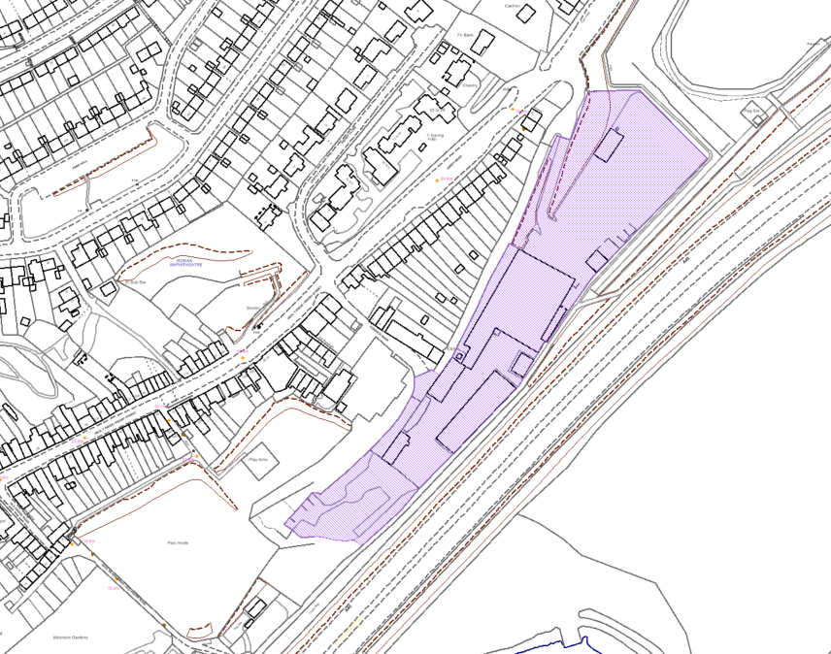

Furnace – PrC2/ExE9
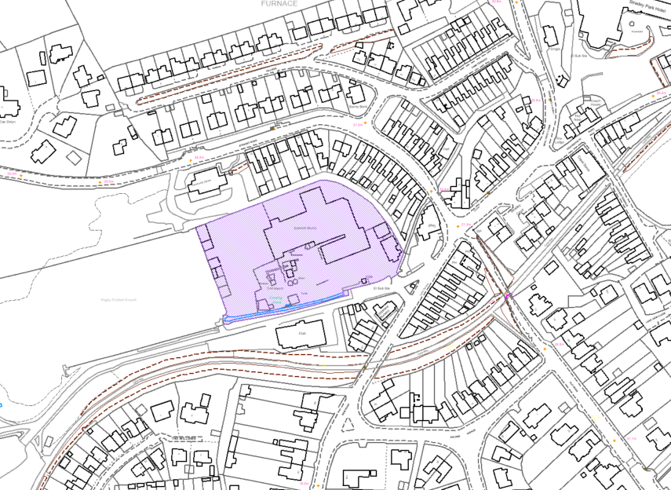

Sandy Road, Llanelli – PrC2/ExE10
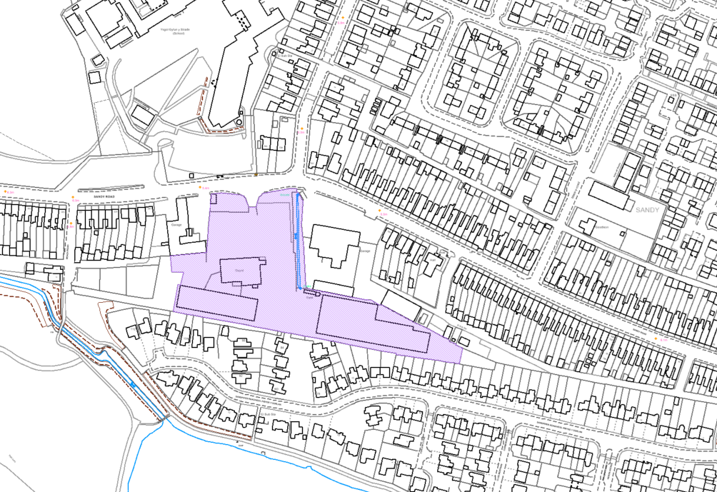

Penygroes Concrete Products – PrC3/ExE18
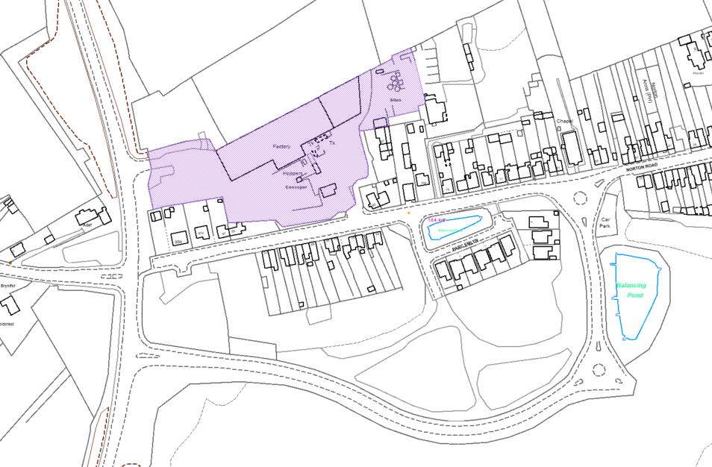

Gwscwm Road, Burry Port – SeC4/ExE5
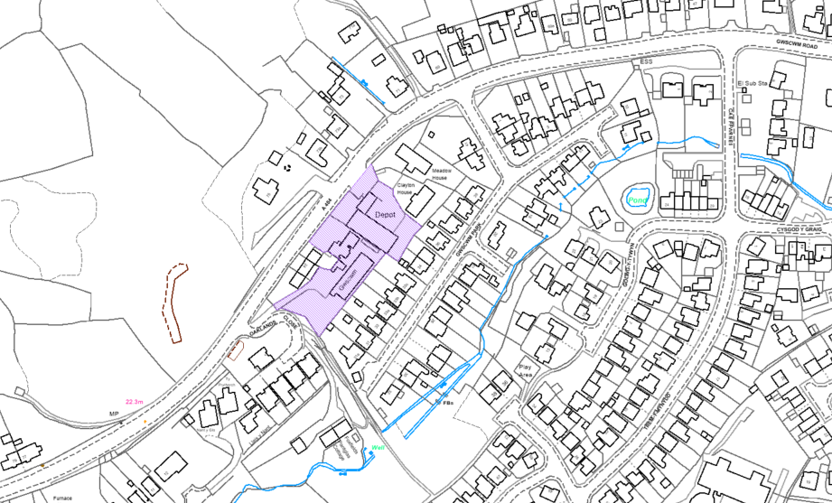

Pembrey Industrial Estate – SeC5/ExE1
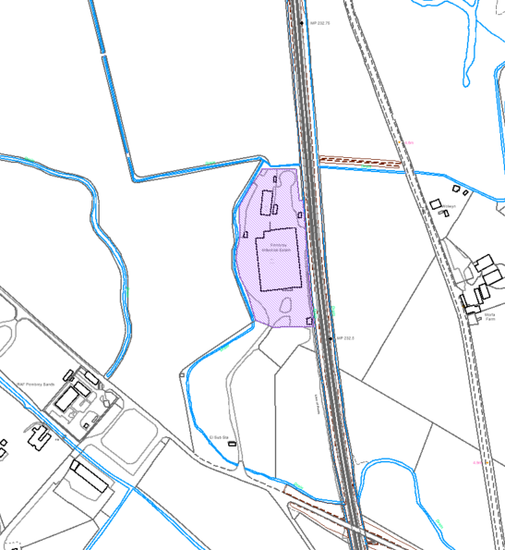

Station Terrace, Llanybydder – SeC13/ExE2
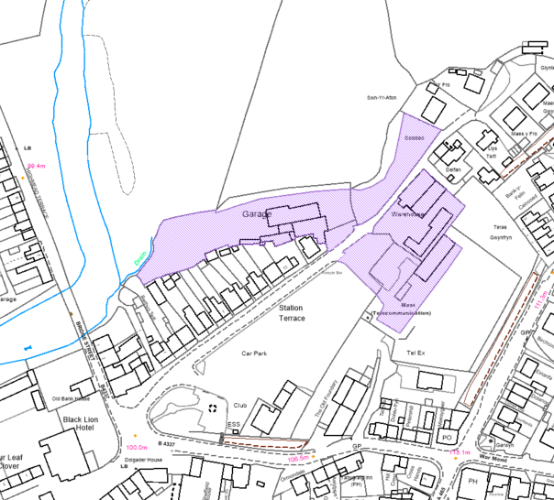

Waterloo Street, Llandovery – SeC15/ExE4
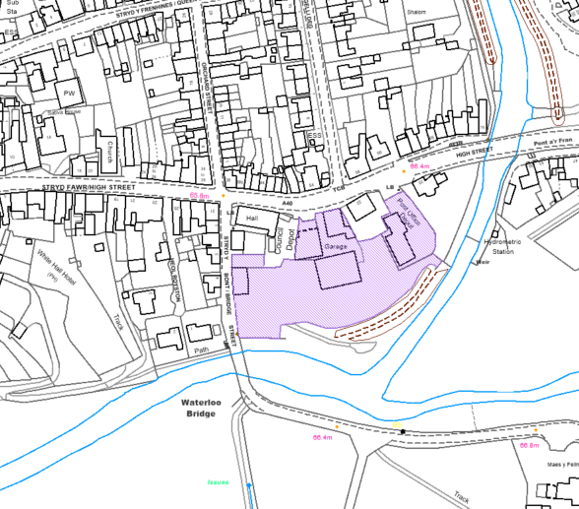

Carmarthen Road Business Park, Llandeilo – SeC16/ExE4
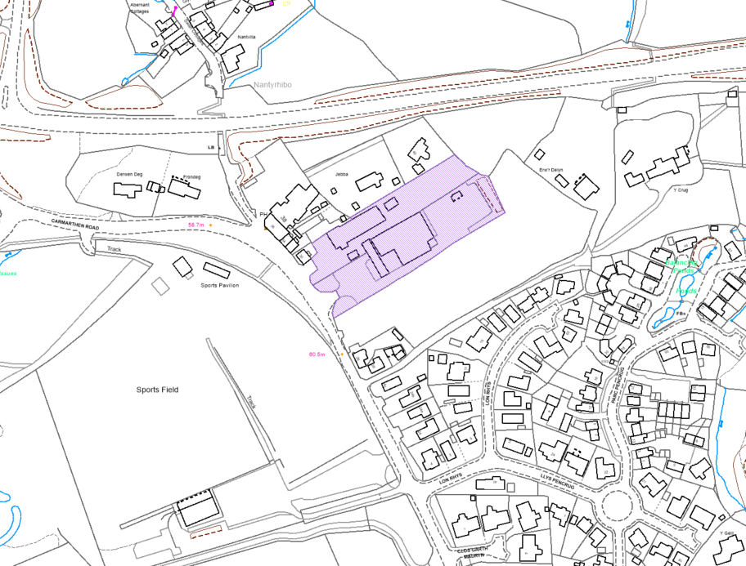

Land adjacent A40 roundabout, Whitland – SeC19/ExE6

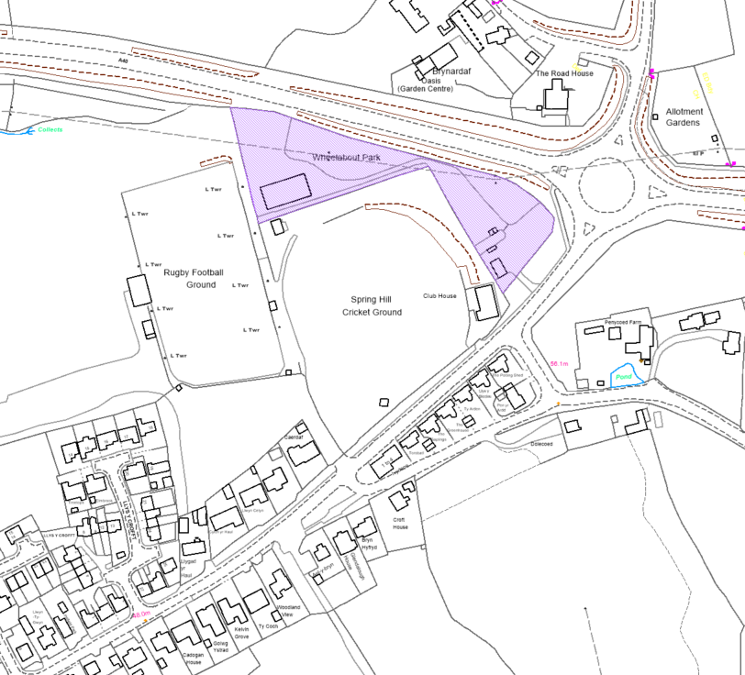

Teifi Timber, Llanllwni – SuV26/ExE1
