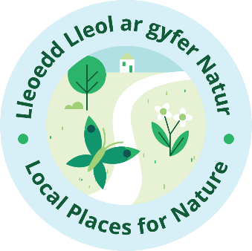
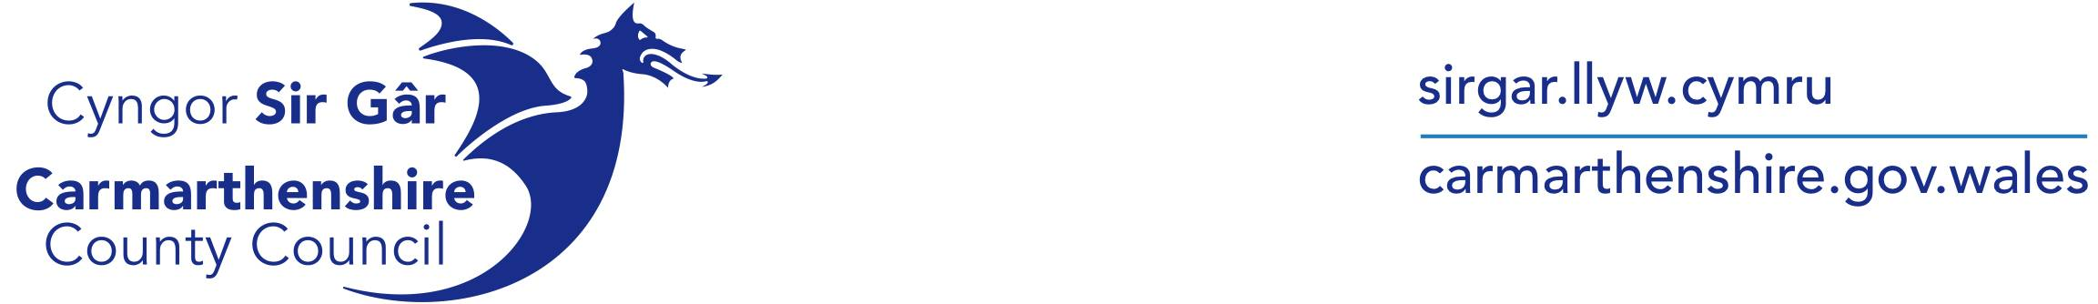

COMMUNITY ACTIVITIES FOR BIODIVERSITY

Local Place for Nature Carmarthenshire is offering grants of up to £1500 to support Community Activities for Biodiversity. The grant is aimed at helping raise public awareness of the importance of biodiversity and to support related community activities.
If you have a project idea and would like to apply, please complete the enclosed application form.

Introduction:

Local Places for Nature is a Welsh Government programme, aimed at creating and supporting projects to restore and enhance nature within local communities. The project focuses on areas of high deprivation and those with the least access to nature in Wales, particularly within urban and peri-urban environments.
Across Carmarthenshire, a variety of projects are being delivered in partnership with the County Council and the Local Nature Partnership, working with a wide range of organisations, groups and individuals within the community to develop strong partnerships and sustainable networks for nature recovery.
We may not always appreciate it, but our wellbeing depends upon the health of the natural environment. If we are to protect and restore it successfully, we need a good plan and we need to work together to achieve it.
You can find out more about Local Places for Nature, Carmarthenshire here.

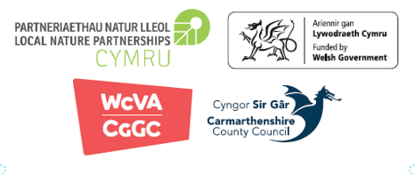

COMMUNITY ACTIVITIES FOR BIODIVERSITY
GRANT OBJECTIVES:

1/. This grant can be used to fund nature-based project activities, such as:
- delivering a public event/activity that will enhance the biodiversity of an area and/or help to improve public understanding of it.
- delivering or receiving public training sessions around biodiversity issues
- coordinating regular volunteer nature-based activities
- creating promotional media and/or artistic activities relating to biodiversity.
You may combine different activity elements of this kind as part of your project proposal.
The grant can cover the material costs of a project activity, but is not intended to support capital purchases of equipment/infrastructure etc. If there are items of this kind that you would need, please contact mcollinson@carmarthenshire.gov.uk for further advice.

2/. You will also need to ensure that beneficiaries of the grant have completed the LPfN survey questionnaires. This will help us to build a better understanding of local people's interests and attitudes, relating to their community and the natural environment and will support the development of future Local Places for Nature projects in Carmarthenshire.

COMMUNITY ACTIVITIES FOR BIODIVERSITY
APPLICATION FORM
To apply for this grant, please complete and return this application form.
It is recommended that you read through the notes and guidance below before completing your application.
If you have any questions about this grant or would like some advice and support around your project idea, please contact mcollinson@carmarthenshire.gov.uk.

Group / organisation Name: | Address:
Phone: | Email:
Project Title: | Project Location  (if different from above):
1/. Please provide details of your proposed project:
(max 500 words)

2/. How will your project help to (a) improve biodiversity, (b) raise public awareness of its importance and (c) promote relevant community activities?

3/. How will you ensure that LPfN surveys are completed effectively?
(Please see point 5 of notes and Guidance below)

4/. How will the outcome(s) of your project be sustainable in the future?

5/. Please confirm whether the location of your project will be accessible to the public?

Yes ☐ / No ☐

Please provide details:

6/. Do you have permission from the landowner of the proposed project site?
Yes ☐ / No ☐

Please provide details:

7/. Does your group have suitable public liability insurance for the proposed activities?

Yes ☐ / No ☐

Please provide evidence of this with your application.

8/. Please provide details of how much funding you require, and how it will be spent (e.g., volunteer hours, materials, activities etc):

Beneficiaries | Volunteers | Staff | Other

Details of Material costs | Details of Activity Costs | Net | VAT | Gross
 |  |  |  | £
 |  |  |  | £
 |  |  |  | £
 |  |  |  | £
 |  |  |  | £
 |  |  |  | £
 |  |  |  | £
 |  |  |  | £
 |  |  |  | £
 |  |  |  | £
 |  |  |  | £
 |  |  |  | £
 |  |  |  | £
 |  |  |  | £
 |  |  |  | £
Total |  |  |  | £
9/. How many people do you think will benefit from this activity?

9/. Please provide the Status of your organisation (If you are a Charity please provide your reference number)

Name of Organisation’s
Financial Account
Sort Code
Account Number

How many authorised people have to sign to pay money out of this account?

 | Name(s) & Position | 1
 |  | 2
 |  | 3
Can your organisation reclaim VAT? |  |  | Yes  No | VAT Reference No:
N.B If your organisation is VAT registered, we will not pay your VAT costs through the Grant, as you will need to claim this cost yourself.

10/. Please include any other relevant information that you may wish to include here:

CCC is a retrospective funder. Groups must pay upfront for all project expenditure and claim the allocated funding from Carmarthenshire County Council. Any expenditure incurred prior to the ‘Community Fund Offer Letter’ being issued, cannot be considered, this also includes where contracts have been signed or orders placed.

The information in this application form will be held by the Authority in its records. Information given will also be used by officers of the Authority for monitoring, review and analysis of its Grant Schemes.

Application Checklist and Supporting Documentation

Copy of Governance Document (e.g. Constitution)
Accounts/Bank Statements
Proof of landowner permission
Proof of Personal Liability Insurance

Declaration

I declare that the information given on this form is accurate and true.

Please provide 2 signatures on behalf of the group

Signatory 1 Signatory 2
Signature
Print names:

Position within the Group:
Date:

‘Mae croeso i chi gysylltu gyda’r cyngor trwy gyfrwng y Gymraeg neu’r Saesneg.
You are welcome to contact the council through the medium of Welsh or English’
Carmarthenshire County Council collects personal data about you using this form so that we can deal with your application. To find out more about how we use your information, please contact Data Protection Officer, Carmarthenshire County Council, County Hall, Carmarthen, SA31 1JP. Email: dataprotection@carmarthenshire.gov.uk or Tel: 01267 224127 to obtain our Privacy Notice, or visit our website www.carmarthenshire.gov.wales.

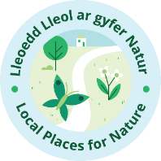

COMMUNITY ACTIVITIES FOR BIODIVERSITY
Notes & Guidance:

1/. Applications will be considered and scored on the scale and value of their impact i.e. benefits to the local community, biodiversity and breadth of engagement.

2/. A focus on partnership working is welcomed and priority will be given to projects that can demonstrate collaborative approaches.

3/. This grant scheme is only applicable to organisations and project activities that are based within the County of Carmarthenshire.

4/. Further details and guidance relating to biodiversity can be found here:
Biodiversity (gov.wales)
Environment (Wales) Act 2016 – Frequently Asked Questions

5/. Local Places for Nature Survey Questionnaires can be completed by volunteers/beneficiaries of your project, as well as by other members of the public that you engage with. Ideally, we would also like to see volunteers reach outside of your organisation’s network and approach their peers/ neighbours/relatives etc. Outcomes from survey work will need to be verified on the LPfN Engagement Platform, so please ensure that your organisation name is included (within the relevant field) at the end of each survey response.

6/. Your volunteer time spent doing engagement work around the LPfN surveys can be included within your costs for the project. Volunteer time of this nature should be costed at £20 / hour, including (for example) travel expenses, training, supervision, facilities, insurance etc.

7/. Successful applicants will be provided with an Offer Letter, along with the grant Terms and Conditions, which must be signed and returned before starting the project

8/. Once the grant offer Terms and Conditions have been returned and any procurement requirements and grant special conditions have been met, you will need to submit your grant claim, itemising you agreed costs.
9/. Payments of grant awards will be retrospective and will be on submission of evidence of expenditure in the form of original paid Invoices and relevant Bank Statement, evidencing project expenditure.

10/. Volunteer hours for survey work can be invoiced for directly, but only for the hours as agreed.
11/. You will need to provide a brief written account of your project and some photos of the outcome(s).

12/. You will need to have completed the project and claim by the 1st of January, 2026.

13/. Recipients must have suitable public liability insurance for any work carried out under the scheme and will need to provide evidence of this prior to being accepted for the grant.
14/. Organisers are responsible for ensuring suitable risk assessments and management throughout the project.

