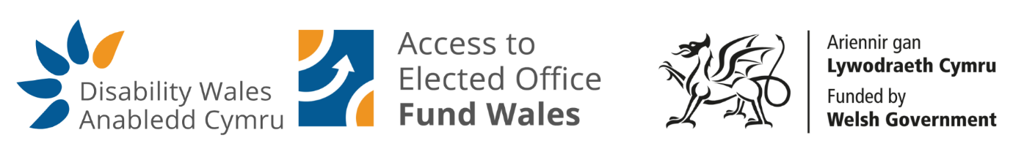

RE: Promoting Equal Access to Local Democracy – Access to Elected Office Fund Wales

Dear Sir/Madam

Disability Wales is the national membership body of Disabled People’s Organisations in Wales and we are running the Access to Elected Office Fund Wales. We invite your support in promoting this important initiative to potential candidates in your area.

This unique Fund provides financial support to disabled candidates standing in the 2026 Senedd and 2027 Local Government elections. It is delivered by Disability Wales and funded by the Welsh Government.

The Fund covers impairment-related costs that can create barriers to participation in elections, including:

- British Sign Language (BSL) interpreters
- Personal assistants
- Accessible transport
- Assistive technology
- Other disability-related adjustments needed for campaigning

Disabled people remain significantly underrepresented in political life. This represents a loss of opportunity for disabled people and a loss of talent in decision-making bodies such as local, town and parish councils. The Access to Elected Office Fund Wales is a practical and impartial programme designed to change that by ensuring disabled people can participate in political life without barriers.

We would be grateful if you could help by:

- Sharing information about the Fund through your local authority’s communications channels and election webpages;
- Signposting the Fund to individuals enquiring about standing for election; and
- Encouraging inclusive practice in local democratic engagement and candidate support.

All applications to the Fund are handled confidentially and independently by Disability Wales. The Fund is open to anyone who meets the eligibility criteria, regardless of political affiliation. Independent candidates can also apply.

We would also welcome the opportunity to meet with you, or with colleagues responsible for democratic services and equality, to discuss how Disability Wales can work with you to:

- Promote awareness of the Fund among potential candidates;
- Strengthen inclusive participation in local democracy; and
- Support equality and representation at community and council level.

Please get in touch to arrange a suitable time for this discussion.

Thank you for your continued commitment to equality and inclusion. We look forward to working with you to ensure that disabled people can participate fully in Welsh democracy.

Kind regards,

Jessica Hatchett
Civic Participation Officer

