CARMARTHENSHIRE
REVISED LOCAL DEVELOPMENT PLAN (2018-2033)
EXAMINATION

Hearing Session 14 – Additional Site Allocations (Clusters 3 - Ammanford including Betws and Penybanc, 4 – Newcastle Emlyn, 5 – Llandovery and 6 - St Clears and Pwll Trap)

Action Point | Council Response | Inspector’s Comments
AP14/1 – Council to provide planning history details for the additional site SuV25/(i) | - S/24486 Residential development (34 dwellings) (resubmission of application no. S/20874, refused 04/03/10). Outline granted 04/04/2013.  - S/30669 Access – New Estate Road. Approval of Reserved Matters 28/10/2014  - S/32126 Residential development - 34 dwellings - (resubmission of application no s/20874, refused 04/03/10). Approval of Reserved Matters 29/01/2016  - S/33972 discharge of conditions 3, 5, 7, 9, 17, 18, 19 & 20 on S/24486 (contamination conceptual model, construction method statement, arboricultural exclusion zone, invasive species treatment & control method statement, code for sustainable homes, materials statement) and condition 3 on S/32126 (landscape management and maintenance). Approval of details reserved by a condition 05/08/2016  - PL/04391 Discharge of Condition 4 on S/32126 (Plot Foundations). Refusal of details reserved by a condition 20/09/2022.  - PL/04876 Discharge of Condition 4 on S/32126 (Plot Foundations). Approval of details reserved by a condition 29/08/2023.  - PL/04755 Non-Material Amendment to S/32126 (Plans). Approval of non-material Amendment 25/08/2023.  - PL/06645 Non-Material Amendment to S/32126 (Changed to approved drawings). Approval of non-material amendment 08/01/2024  - PL/04761 Modification of section 106 agreement on S/24486 (modification to reduce the number of affordable units from 8no. to 4no. (designed to DQR standard) plus a £11,000 commuted sum in lieu). Modification of Section 106 Agreement agreed 10/04/2024.  - PL/09684 Non-Material Amendment to S/32126 (Changes to approved drawings). Refusal of non-material amendment application 21/08/2025.  - PL/09783 Non-material amendment to S/32126 (Amendments to House Types). Pending. | Agreed.
AP14/2 - Council to provide a map showing a revised boundary for site allocation PrC3/(v) | A representation made by the landowner seeks an amendment to the boundary of PrC3/(v). The proposed amendment is shown below with the additional land to be included shown in red.  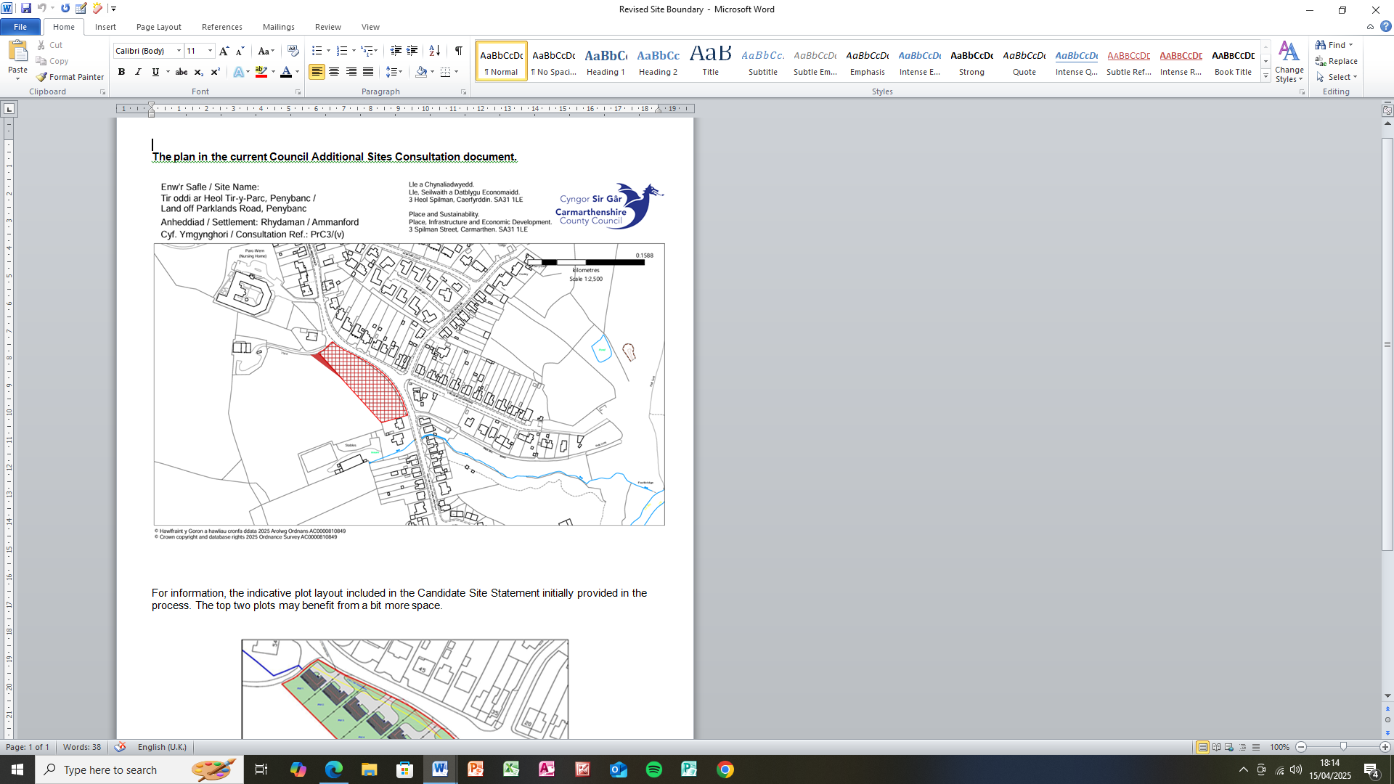 | Agreed.

