Environment (Wales) Act Forward Plan December 2025
APPENDIX 1 - Case Studies
CASE STUDY 1: ACTION 18039. When opportunities arise secure S106 contributions from developers to deliver off site net benefit for biodiversity on land in the management control of CCC.

A planning application (S/38285) at North Dock resulted in a compensation project to create ‘Brownfield’ habitat within an area of the Millennium Coastal Park. Working with a consultant ecologist 200 tonnes of Baglan Slag (formed as part of steelmaking process and sometimes used in the construction industry) was mixed with sand and spread over 1000 m2. The by-product is known to absorb carbon and can be seen as helping in the fight against climate change. The project included the establishment of local provenance coastal wildflowers and also serves as a repository for rarer native plants such as wild Liquorice and Sea Stock, in addition this open area will encourage the spread of nearby existing wildflowers to spread into an area which has been reclaimed from amenity grassland and create a species rich ‘open mosaic habitat’.

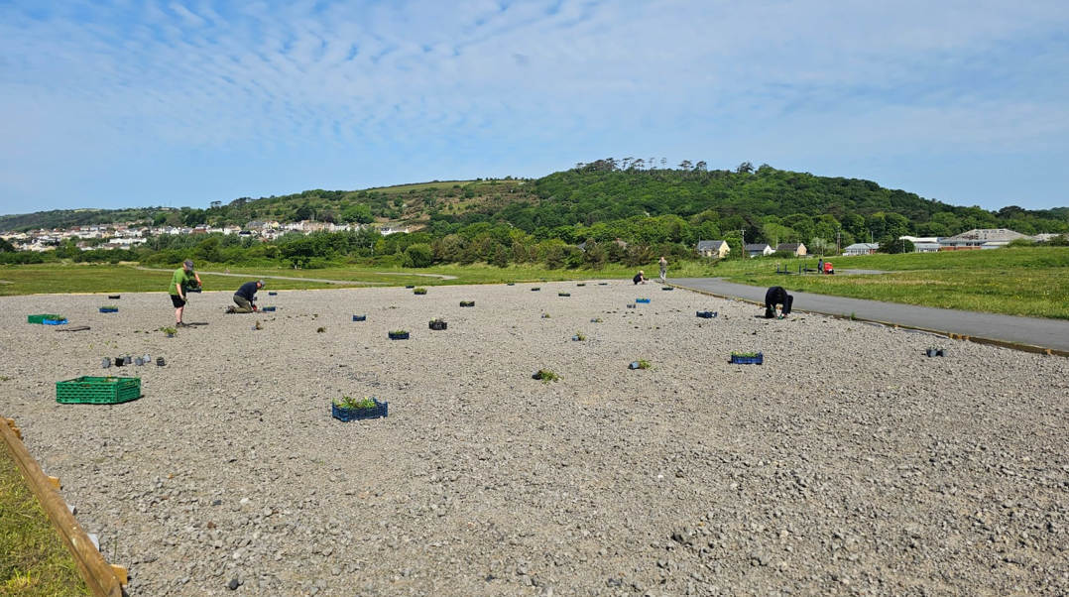

NRAP Objectives met:
• Increase resilience of our natural environment by restoring degraded habitats and habitat creation.

Press: Slag heaps could be Wales' biodiversity hero - BBC News

CASE STUDY 2 ACTION 18060. Develop and promote an integrated approach to the design of nature-based, low maintenance SUDS schemes that will contribute to landscaping requirements, and provide green infrastructure, and net benefit for biodiversity for larger/major developments
NRAP Objectives met:
• Increase resilience of our natural environment by restoring degraded habitats and habitat creation.

Natural Flood Management (NFM) Scheme
This innovative Natural Flood Management scheme in Ammanford is a nature-based flood alleviation scheme that provides a higher level of flood protection for more than 20 properties situated around Margaret Street.
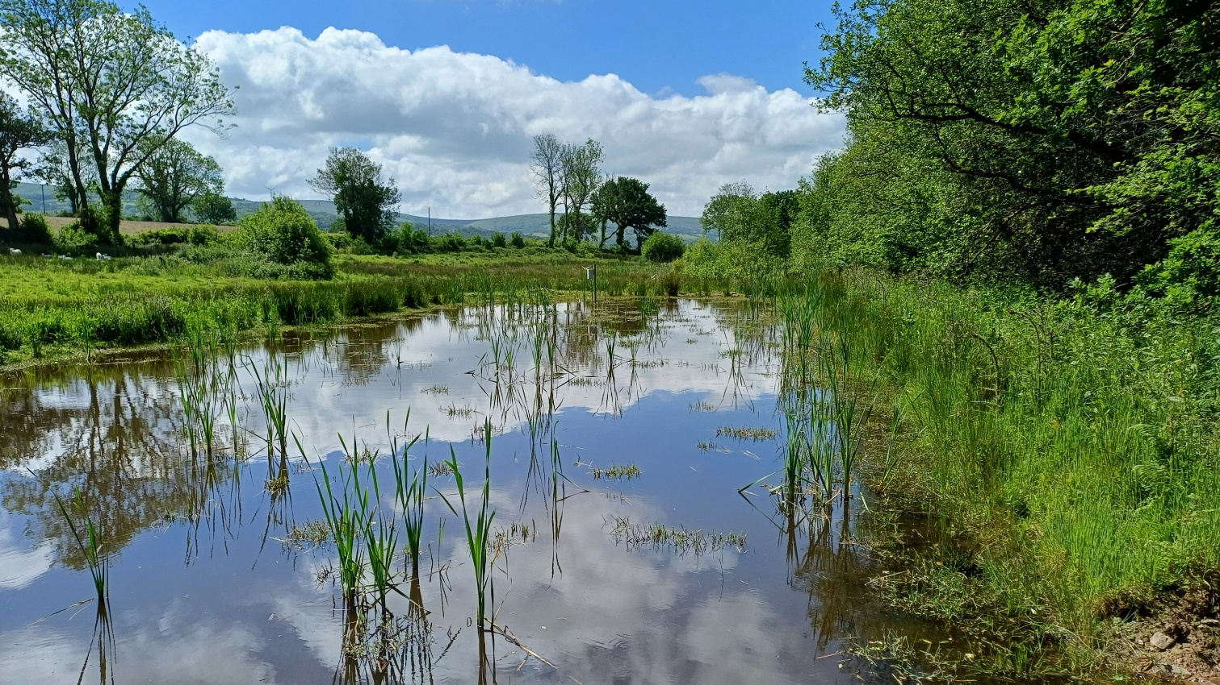
Natural Flood Management (NFM) Scheme - Carmarthenshire County Council

CASE STUDY 3. ACTION 18040 Seek funding and continue to deliver the Carmarthenshire Bogs Project on key sites

NRAP Objectives met:
• Safeguard species and habitat of principal importance and improve their management
• Increase resilience of our natural environment by restoring degraded habitats and habitat creation.

WG funding (Enabling Natural Resources and Well-being and Local Places for Nature) has been used to cut firebreaks and undertake contour bunding (working with local skilled contractors) to keep water in the in the bog and reduce the fire risk. NRW have reviewed the contour bunding and are advising on future recommended action.
Contour bunding can significantly benefit bogs by helping to restore and maintain water levels, which is crucial for the health and function of these ecosystems. By creating low-level banks of peat along the contours of the bog, bunds can slow down water flow, trap water in shallow pools, and prevent it from draining away, thus raising the water table and keeping the peatland wet. This helps to create suitable habitat for various bog species, including sphagnum mosses, invertebrates, and birds.
