CARMARTHENSHIRE 10 TOWNS
Town Centre Digital Screen Fund

Guidelines for Applicants


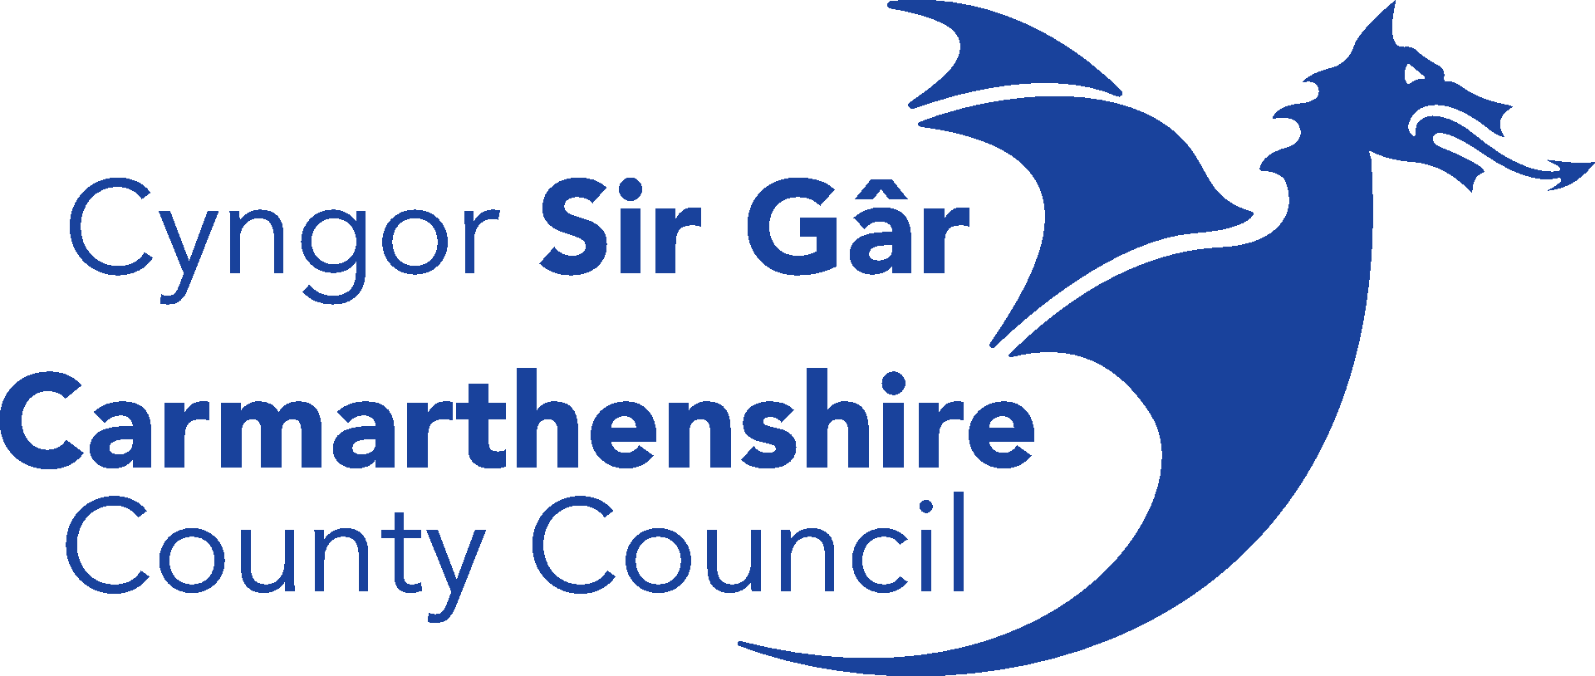

Introduction

Carmarthenshire County Council has made significant progress in enhancing digital infrastructure across its principal towns through a range of initiatives designed to improve visitor experience, promote local businesses, and strengthen community communication. Several towns have already benefited from the installation of digital information boards, supported through funding programmes administered by the Authority as part of the Ten Towns Programme.

To ensure a consistent level of digital infrastructure across all ten towns, this fund will enable eligible town and community councils to procure, install, and operate digital information boards within their respective town centres.

The initiative will support the Council’s wider objectives of economic regeneration, tourism promotion, and community engagement, ensuring equitable access to digital visitor information and strengthening the vitality and resilience of Carmarthenshire’s rural market towns.

Eligible Areas

Projects located in the following towns are eligible for support.

- Cross Hands
- Cwmaman (Garnant and Glanaman)
- Kidwelly
- Llandeilo
- Llandovery
- Newcastle Emlyn
- Laugharne
- Llanybydder
- Whitland
- St Clears

Projects located in towns where there are currently no existing digital screens already installed will be prioritised.

Eligible applicants

- Constituted Voluntary and Community Groups e.g. business forum, town centre partnerships
- Town and Community Councils

Eligible expenditure

- Expenditure associated with the supply, installation, software and connection of new town centre digital screens
- Expenditure associated with training, software and/or hardware upgrade of existing town centre screens
- Costs associated with gaining statutory consents are eligible for support
- Costs associated with content creation and translation

Fund Criteria
.
- Digital boards must comply with relevant accessibility and equality standards, including visibility, readability, and language requirements.

- Boards must have bilingual capability and operate bilingually

- Installations must align with local planning, heritage, and highways regulations.

- Preference will be given to proposals that demonstrate environmental sustainability, such as low-energy or solar-powered systems.

- Applicants must demonstrate how they will maintain and regularly update the digital content, ensuring information remains accurate, relevant, and reflective of local priorities and events.

The Grant

- Grants of up to 100% of the total project cost will be available, however projects are encouraged to source match funding to extend project benefits.

- Applicants can apply for a maximum of £10,000 per project (location)

- Organisations can submit more than one application for consideration for support from this fund.

- In most cases, applicants will be required to gain advertising consent from the local planning authority. Advertising consent Applications must be submitted prior to submitting grant application. More information can be found here Advertisement consent - Consent types - Planning Portal. Costs associated with gaining necessary consents can be included in grant application.

Considerations when applying for support

- Ensure you have referred to the procurement guidelines and sourced the relevant minimum number of quotes required within monetary thresholds.
- Ensure you have considered any on-going costs for screen maintenance, connectivity and relevant licences
- Consideration for costs associated with gaining necessary consents
- What content will be displayed on the digital screens? Who will create this and are there any costs associated with creating content?
- Ensure that the screen has capability to display information in English and Welsh
- Have you identified who will be responsible for maintaining the content on the screen? Will they require training? Is there a cost associated with this training?
- The content displayed on screen will need to be fully bilingual. Do you need to include translation costs in your application for support?
- How will the screen gain electric connection? Have you included installation costs in your application for support?
- How will the screen gain internet connection? Have you included this cost in your application? Please note that ongoing costs are ineligible for support, yet you may include long- term connectivity costs if a one off cost.

Outputs

Each project must identify which of the following outputs will be achieved as a result of the funding:

Number of amenities/facilities created or improved
Number of people reached
Number of organisations receiving grants

Each project must consider how they will demonstrate output achievement and provide information to Carmarthenshire County Council.

Submitting an application

In order to be considered for support, you will need to complete a full application. You will need the following information:
- Proof of land ownership or landowner’s consent (if applicable)
- Proof of match funding (if applicable)
- Quotes from chosen suppliers to undertake works/provide goods or services
- Details of any applications for statutory consent e.g. registered application number
- Location plan

Panel review
Each application will be assessed by an Economic Development panel and given final approval by Head of Economic Development and Property.

Accept the grant offer
We will let you know the final outcome of your application following the panel review. If your application is successful and you are awarded funding, we will email you the terms and conditions of the grant. You must accept these terms within 14 days.

Payment of grant
- You will be required to provide evidence that all approved expenditure has been paid and submit a claim form for reimbursement of eligible expenditure based on your project’s approved intervention rate. Staged claims to support cashflow can be requested.
- Each request for payment will require the following documentation to be submitted;
- Claim form
- Evidence of compliance with procurement rules
- Invoice from chosen supplier

- Bank statement showing proof of payment

- Equipment serial number (for equipment purchases only)

- This grant will be retrospective however where an organisation is unable to process claims in this way a request can be made as part of the main application for payments to be made on incurred expenditure basis.

Variations

- If the eligible works expenditure is lower than anticipated in the grant offer, the grant will be reduced on a pro rata basis.

or request a deviation
- If you change any of the element of your project detailed in your application, you must let us know as soon as possible. You will need the following information:
- Project element you are changing and the reason why you've decided to do this
- New items / suppliers and costs
- New quotes, please read procurement rules for guidance.

Assess your claim / pay funds
- Once we've received your claim form, we will check that you have complied with the terms of the grant. If we need any additional information before we can release the funds, we will let you know. We will email you to let you know when your claim has been approved.
- It can take up to 20 working days from when we receive your claim form to complete this assessment and set up a payment into your bank account.

The Grant

- The grant can only be offered in those cases where the Council is satisfied that without such aid the project will not proceed, either on the scale envisaged or within a reasonable time frame.

- The amount of the grant offered to each project will be determined by the County Council.

- The amount of grant specified in the grant offer letter is the maximum County Council contribution towards the project. In the event of there being any reductions in the cost of the approved project, the County Council will make a pro-rata reduction to the amount of grant originally offered.

- Grant will normally be awarded exclusive of VAT. If the applicant cannot recover VAT this may be accepted as an eligible cost at the discretion of the County Council, subject to the applicant undertaking to repay to the County Council any VAT element which later becomes reclaimable from HM Customs and Excise as a result of a change in the applicant’s VAT status.

Application for grant

- In making an application for grant, the applicant will warrant to the County Council that all information provided in connection with and accompanying both application forms is and remains true and accurate in all respects and that any estimates and anticipated forecast outputs or other facts were made after due and careful research and investigation. The warranty will be deemed to be given again at the time the applicant submits the grant claim form.

Procurement

- When making a purchase or paying for a service, applicants should aim to get value for money whilst offering a range of businesses the opportunity to provide those goods or services in a fair and transparent manner.

- The applicant must therefore ensure that the following procurement procedures set out in Annex 1 of this guidance document are adopted according to the estimated value (exc. of VAT) of the contract at quotation/pre-tender stage. Your decision must demonstrate best value and you must keep records which supports your decision.

- Failure to fully comply with the procurement thresholds will render the costs ineligible for assistance under this fund.

- Please refer to Annex 1 of the guidance document for the procurement rules.

Avoiding conflicts of interest

- It is possible that project applicants, or persons connected with them (such as relatives, business partners or friends) may wish to carry out works associated with the project being proposed for support. This is not unacceptable, but the applicant will need to make sure that they conduct the transaction as openly and as transparently as possible.

- Applicants must inform Carmarthenshire County Council officers should this be the case and advice will be given to applicant on necessary process to be undertaken in relation to any perceived conflict.

Repayment of grant

Funding shall be withheld and/or, insofar as payment has been made, the grant recipient shall repay funding either in whole or in part, including if:

- a domestic check by the Authority, the National Audit Office, Audit Wales, or any of their representatives, identifies circumstances whereby a full or partial repayment of funding is due, or, if the Authority otherwise requires the funding to be withheld, reduced, cancelled or recovered.
- there has been an overpayment of funding.
- the applicant is found to have made any misrepresentation in connection with the application.
- the applicant has breached the provision of terms and conditions of grant.
- during its economic life, the project undergoes substantial change defined as being used for purposes other than those specified in the application, or having a change of owner without notifying Carmarthenshire County Council. The economic life is the period of final payment of the grant.
- Any payments made in cash will be deemed ineligible. Expenditure must be made from applicants bank account to be eligible to be reimbursed.

Monitoring

- The applicant must retain any original invoice, account or other document (including serial numbers of goods purchased) relating to your approved project for ten years from the date of the final grant payment.

- Upon giving reasonable notice, the County Council reserves the right to inspect the property/works or approved project at any time between receipt of a grant application and the expiration of 5 years from the final grant payment date. The County Council may appoint such professionals as it sees fit to undertake such inspection on its behalf.

- This grant fund is awarded under UK Subsidy Control Rules, and the County Council therefore require you to advise us of any public funding you have received any period of 3 consecutive fiscal years immediately preceding your application.

Welsh Language

- The Welsh Language Standards Compliance Notice places a statutory requirement on the Council to ensure that the grants it awards have a positive effect on opportunities for persons to use Welsh, and on not treating Welsh less favourably than English;

- To meet these requirements, you must make every effort to do the following:

- Operate bilingually publicly, giving Welsh a high visual presence and status at every opportunity (promotional materials, posts, press releases)
- Communicate bilingually with the public (emails, press releases, phone call letters)
- Collaborate with partners who promote the Welsh language (Mentrau Iaith, Urdd, Young Farmers, Meithrin, Cymraeg i Blant, Welsh medium Schools, Welsh for Adults, chapels, choirs, local newspapers, forums and networks that promote the Welsh language)
- Ensure that there is a workforce with Welsh language skills, or other arrangements in place, that will enable activity in accordance with the Standards.
- Provide services in person or online in Welsh
- Demonstrate consideration of the linguistic nature of the geographical area in which it is intended to serve, and of how the work is going to have a positive impact on the number of speakers or the use of Welsh*
- *This means that the applicant has a knowledge of the communities of Welsh speakers who may be affected by the provision; positively or negatively. The applicant will need to be aware of opportunities to increase the visibility of the Welsh language and promote everyone's use of Welsh; confident speakers as well as those who can speak only a little Welsh.

Subsidy Control Rules

- This scheme is public subsidy and will be subject to the UK Subsidy Control Rules. UK Subsidy Control Rules means the EU-UK Trade and Cooperation Agreement and (as applicable) the Northern Ireland Protocol; the World Trade Organisation rules; any Trade Agreement that the UK has in place and any subsequent or related legislation.

Submission of applications

Applications should be sent to the following address

RDPSIRGAR@carmarthenshire.gov.uk

This fund will operate on a first come first serve basis

General Data Protection Regulation (GDPR)

- To find out more about how we use your information, please phone 01267 242319 to obtain our Privacy
- Notice, or visit our website www.carmarthenshire.gov.wales

